A CRM Application for The Chai Shop & Co.

User Story:

The Chai Shop & Co. started as a small tea shop and slowly became popular among local customers. As the number of customers increased, the shop found it difficult to manage customer information manually. The owner decided to introduce Salesforce to organize the business. A Salesforce Administrator was assigned to manage the CRM application. The administrator created customer records and organized their information. Regular customers could be identified and their preferences could be maintained. The shop could record customer enquiries and service requests. Employees could easily find customer information whenever required. The administrator created custom fields to store useful business details. Reports were created to understand customer activities and sales information. Dashboards helped the owner view important business data quickly. Salesforce automation reduced repetitive tasks for the employees. The system also helped the shop provide better service to its customers. With Salesforce, the owner could manage the growing business more efficiently. Finally, The Chai Shop & Co. successfully used Salesforce CRM to build better customer relationships and improve its business operations.

1. INTRODUCTION

1.1 Project Overview
The project “A CRM Application for The Chai Shop & Co.” focuses on implementing a Salesforce-based Customer Relationship Management (CRM) system to efficiently manage customer information, business accounts, sales activities, and customer interactions. The system helps The Chai Shop & Co. organize customer records, manage account information, track business activities, generate reports, and improve overall customer relationship management through Salesforce automation and notifications.
The project user story and objectives are defined in the initial section of the project documentation.
Purpose:
The purpose of this user story is to explain how Salesforce CRM helps The Chai Shop & Co. manage its growing customer base efficiently.
It focuses on organizing customer information and maintaining customer preferences in a centralized system.
The story demonstrates how reports, dashboards, and automation can improve business operations.
It also highlights how Salesforce helps employees reduce repetitive work and provide better customer service.
Overall, the user story shows how Salesforce CRM supports better customer relationships and efficient business management.

2. IDEATION PHASE
2.1 Problem Statement (Customer Problem Statement Template)

PS | I am  (Customer) | I’m trying to | But | Because | Which makes me  feel
PS-1 | Sales Owner | Manage customer information and sales activity efficiently | Customer details are difficult to manage manually. | Customer records are stored in notebooks and separate files. | Stressed and inefficient
PS-2 | Sales Employee | Find customer details,prefrence,enquiries and service requests quickly. | Information is scattered and difficult to search. | Customer informations is maintained manually in multiple records. | Confused and delayed.
PS-3 | Regular Customer | Receive better and more personalized service. | My preference and previous interactions  are not always available. | There is no centralized system to maintain customer history. | Disconnecte d and less satisfied

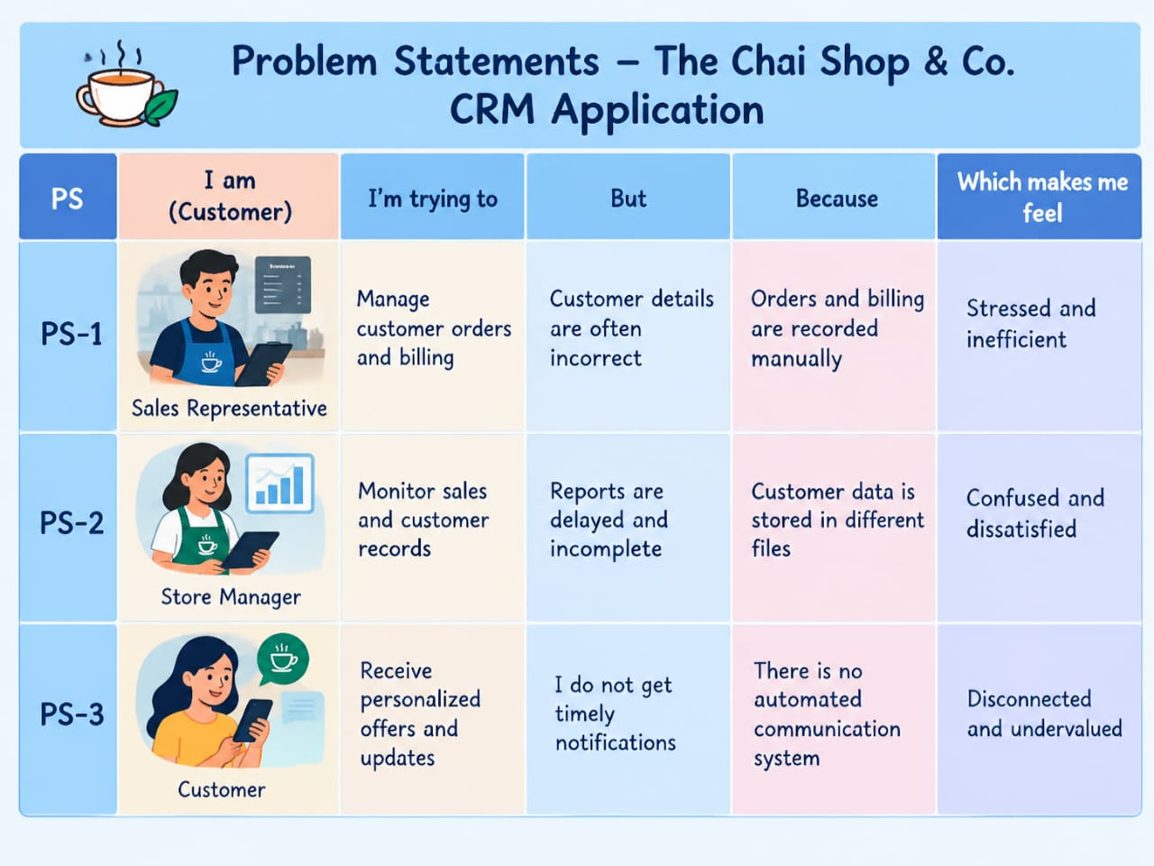

2.2 Empathy Map Canvas
Target Users
- Shop Owners
- Store Employees
- Sales Representatives
- Regualr Customers
- Salesforce Adminstrator
Empathy Analysis

Aspect | Description
Think & Feel | Want simple customer management, accurate information, faster service, and better customer relationships.
Hear | Customer requests, feedback, employee updates, and information about sales and services..
See | Customer records, orders, preferences, enquiries, service requests, reports, and dashboards.
Say & Do | “I need to find customer details quickly.” “I want to provide better service.” “I need accurate sales information.” Create and update customer records, track enquiries, manage service requests, record customer preferences, and view reports.
Pain | Manual records, scattered customer information, difficulty finding old records, repetitive work, and delayed updates.
Gain | Centralized customer information, faster access to records, automated tasks, accurate reports, useful dashboards, and improved customer service.

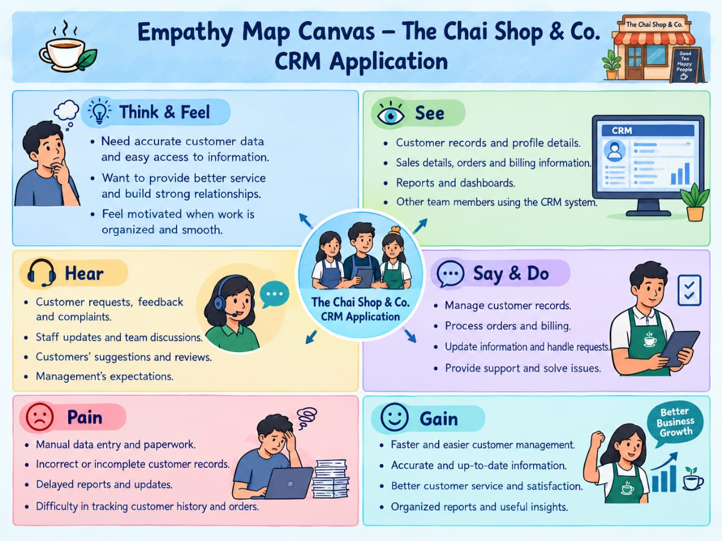

2.3 Brainstorming
Brainstormed Ideas
Manual customer record management

Excel-based customer management

Web-based CRM system

Salesforce-based CRM application

Automated customer notification system

Customer preference management system

Customer enquiry and service request management

Reports and dashboard-based business monitoring
Selected Idea:
Salesforce-based CRM Application for TheChaiShop&Co..

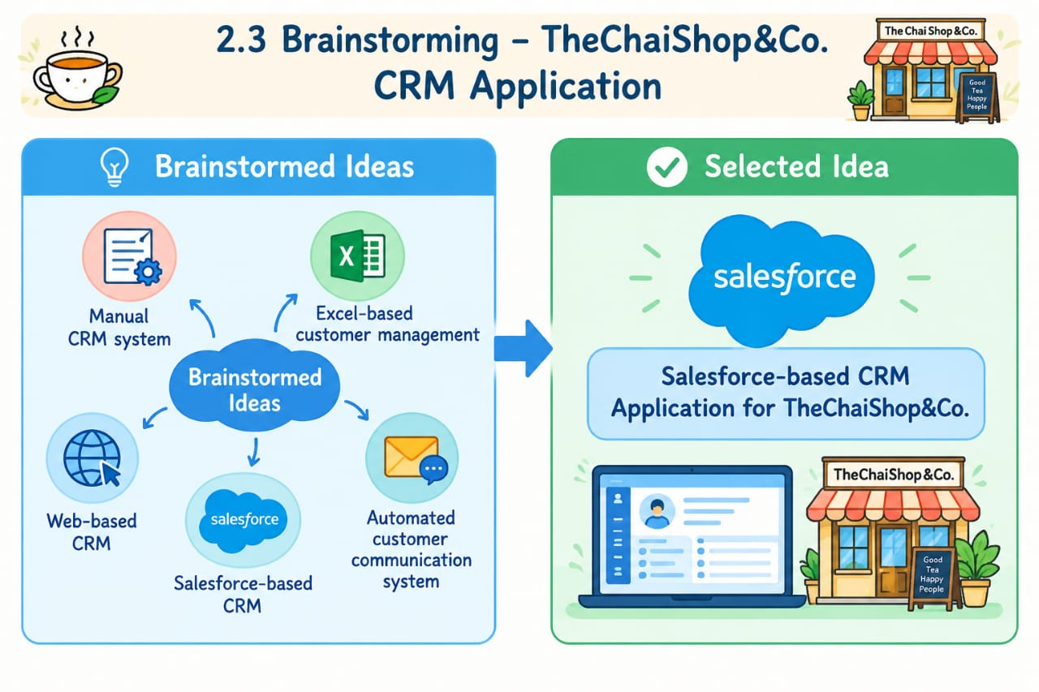

3.REQUIREMENT ANALYSIS PHASE

3.1 Customer Journey Map
Journey Stages:
- Login to Salesforce
- Access CRM Application
- View Customer Information
- Create / Update Customer Records
- Record Customer Preferences
- Manage Enquiries and Service Requests
- Manage Customer Orders
- Automate Customer Activities
- View Reports and Dashboards
- Make Business Decisions
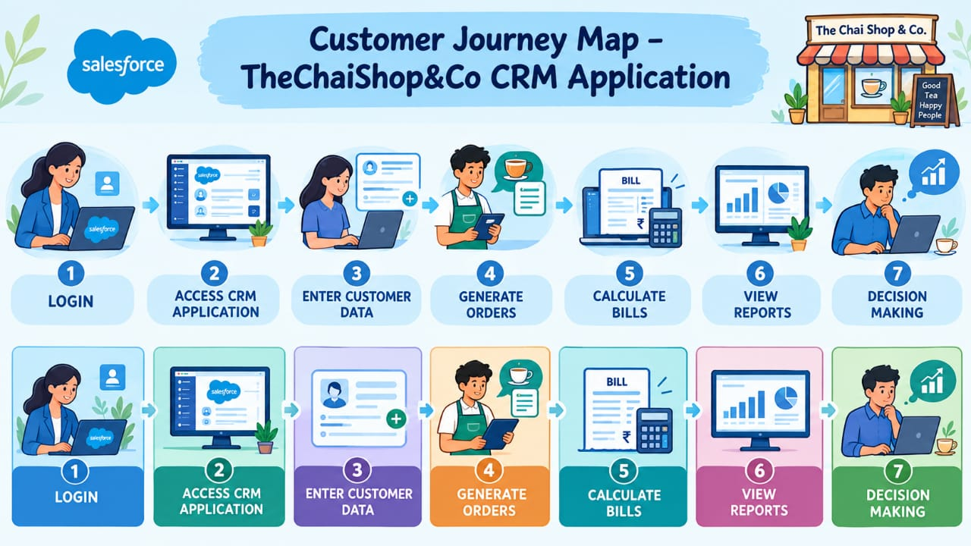

3.2 Solution Requirements
Functional Requirements

FR No | Requirement
FR-1 | User Login
FR-2 | Customer Record Management
FR-3 | Customer Data Entry
FR-4 | Customer Object Management
FR-5 | Customer Preferences
FR-6 | Enquiry Management

Non-Functional Requirements
NFR-1: Usability

The system should be easy to use for sales representatives, managers, administrators, and other authorized users without requiring extensive technical training.

Requirements:

• Simple and intuitive user interface
• Clear navigation menus
• Easy-to-understand forms
• User-friendly dashboards

Example:

A sales representative should be able to search for a customer, enter customer details, update preferences, and create a service request within a few minutes without assistance.

Salesforce Lightning UI provides an easy-to-use interface and simple navigation for CRM activities.

---

NFR-2: Security

The system should protect customer and business information from unauthorized access and ensure that only authorized users can access or modify CRM data.

Requirements:

• Secure user authentication
• Role-based access control
• Appropriate object and field permissions
• Protection of customer information
• Controlled access to reports and dashboards

Example:

Only authorized Salesforce users should be able to view or modify customer records, enquiries, and service requests according to their assigned permissions.

Salesforce security and permission settings help control access to CRM data.

---

NFR-3: Reliability

The system should provide consistent and accurate CRM services and maintain customer information without unnecessary data loss or errors.

Requirements:

• Accurate customer records
• Consistent data storage
• Data validation rules
• Reliable automation and flows
• Prevention of incomplete or incorrect data

Example:

When a sales representative creates a new customer record, the required information should be validated before the record is saved. Customer enquiries and service requests should also remain available for future reference.

Salesforce validation rules and automated processes help maintain reliable data.

---

NFR-4: Performance

The system should provide quick responses when users search, create, update, or view customer information.

Requirements:

• Fast customer record retrieval
• Quick navigation between CRM pages
• Efficient data entry and updates
• Fast report generation
• Smooth dashboard operation

Example:

A sales representative searching for a customer's name should be able to quickly find the customer's details, preferences, enquiries, and service requests.

Salesforce Lightning provides efficient access to CRM records and business information.

---

NFR-5: Availability

The system should be available to authorized users whenever they need to access customer information and perform CRM activities.

Requirements:

• Reliable access to CRM records
• Availability of customer information
• Continuous access to important business data
• Reliable reports and dashboards
• Minimal service interruption

Example:

A manager should be able to access customer records, service requests, and dashboards whenever required to monitor the activities of The Chai Shop & Co.

Salesforce provides cloud-based access to CRM information through supported devices and browsers.

---

NFR-6: Scalability

The system should be capable of handling an increasing number of customers, enquiries, service requests, and users as The Chai Shop & Co. grows.

Requirements:

• Support increasing customer records
• Support additional users
• Handle growing enquiry and service-request data
• Allow new fields and objects to be added
• Support expansion of reports and dashboards

Example:

As The Chai Shop & Co. expands to more customers or branches, the CRM should be able to maintain additional customer records and business information without requiring a complete redesign of the application.

Salesforce provides configurable CRM features that can be extended as business requirements grow.

3.3 Data Flow Diagram
Customer→ Management→ Enquires/Service Requests→ Automation→ Reports → Dashboards.
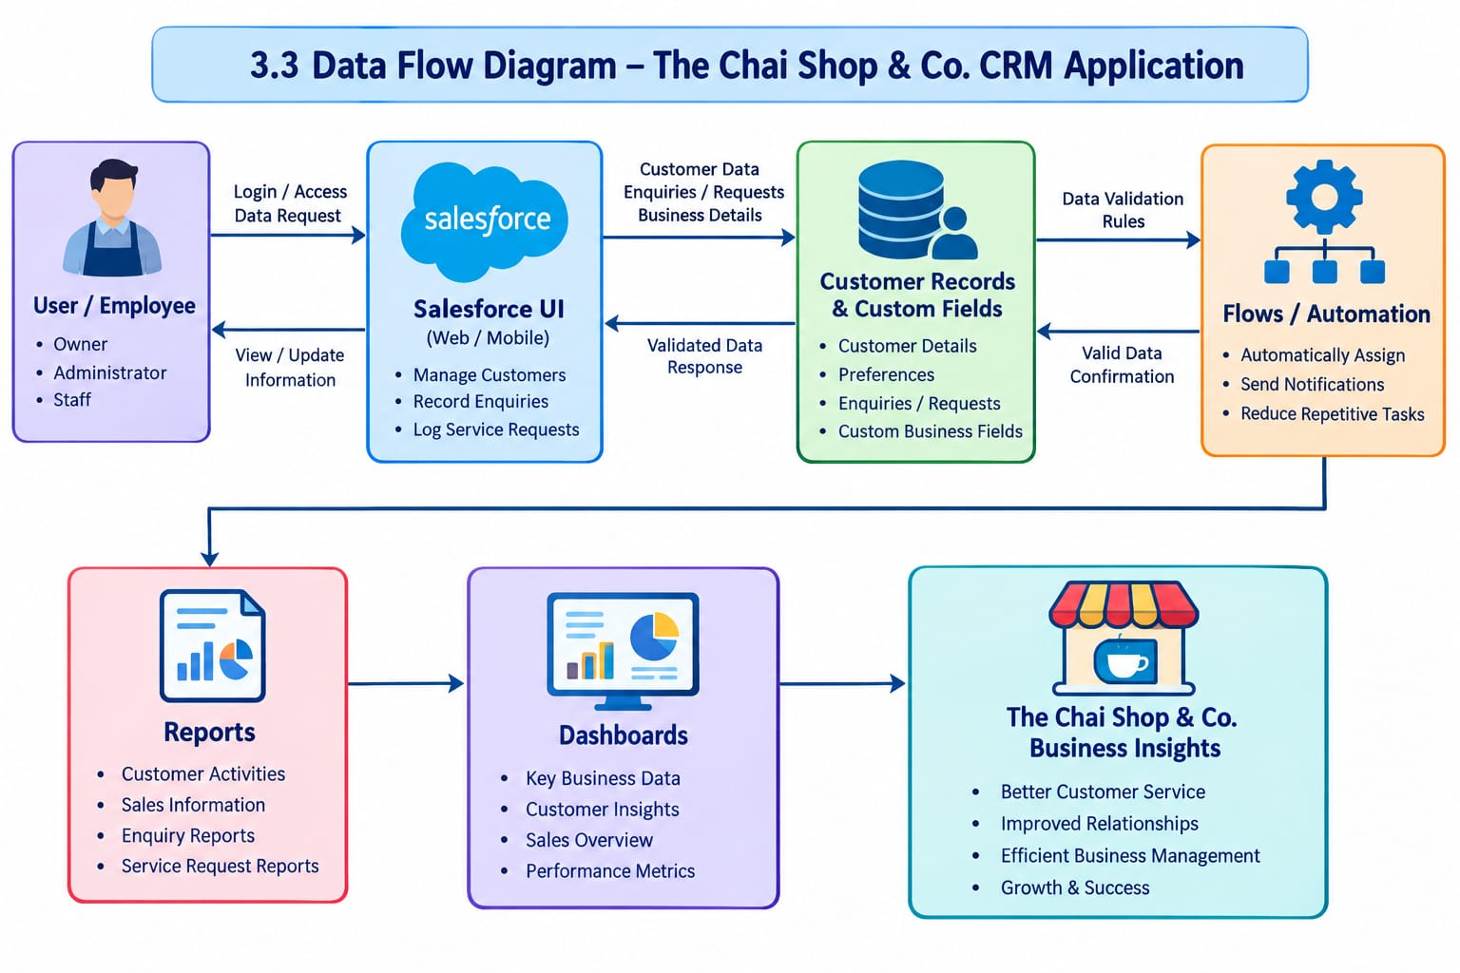

3.4 Technology Stack

Layer | Technology
Frontend | Salesforce Lightning
Database | Salesforce Cloud
Automation | Flows
Backend | Salesforce Platform
Analytics | Reports & Dashboards

4. PROJECT DESIGN PHASE

4.1 Problem–Solution Fit
The CRM system replaces manual records with automated data management. Cloud storage prevents data loss, dashboards improve analysis, and real-time reports eliminate delays. This ensures accurate and timely business insights generation.
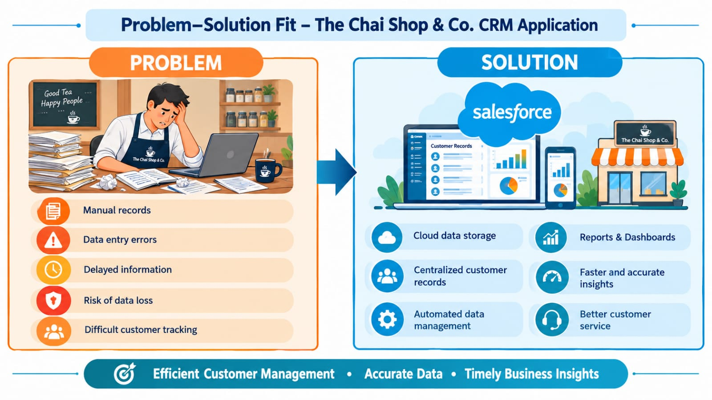

4.2 Proposed Solution
Functional Requirements

Parameter | Description
User Login &  Authentication | | Allows authorized administrators and employees to securely access the CRM system using valid Salesforce credential.
Customer Record Management | Allows users to create, view, update, and manage customer details such as name, contact number, address, and preferences.
Customer Preference Management| | . Maintains customer preferences and information to help the shop provide personalized service to regular customers.
Enquiry Management | Allows employees to record and manage customer enquiries and follow up when required.
Service Request Management | Enables users to record, track, and update customer service requests.
Customer Field | Provides additional fields to store useful business information specific to The Chai Shop & Co.
Validation Rules | Ensures accurate and complete data entry by validating important customer and business information.
Records Types & Page Layouts | Provides suitable record types and page layouts for organizing different customer and business records.
Picklists | Maintains standardized values for fields such as customer type, enquiry status, service request status, and preferences..
Workflow & Flow Automation | Automates repetitive tasks such as updating records, assigning information, and triggering notifications using Salesforce Flows.
Report Generation | Generates reports related to customers, enquiries, service requests, and business activities.
Dashboard  Visualization | Displays important business information through charts, graphs, and dashboard components for quick analysis.
Data Storage & Recovery | Stores customer and business information securely using Salesforce Cloud.
User Role  Management | Controls access to CRM information according to the responsibilities and permissions of administrators and employees.

4.3 Solution Architecture
Architecture Layers
- Presentation Layer – Salesforce Lightning UI
- Application Layer – Salesforce Flows and Automation
- Data Layer – Customer and Account Objects
- Analytics Layer – Reports and Dashboards
This layered architecture ensures modularity, scalability, and maintainability.
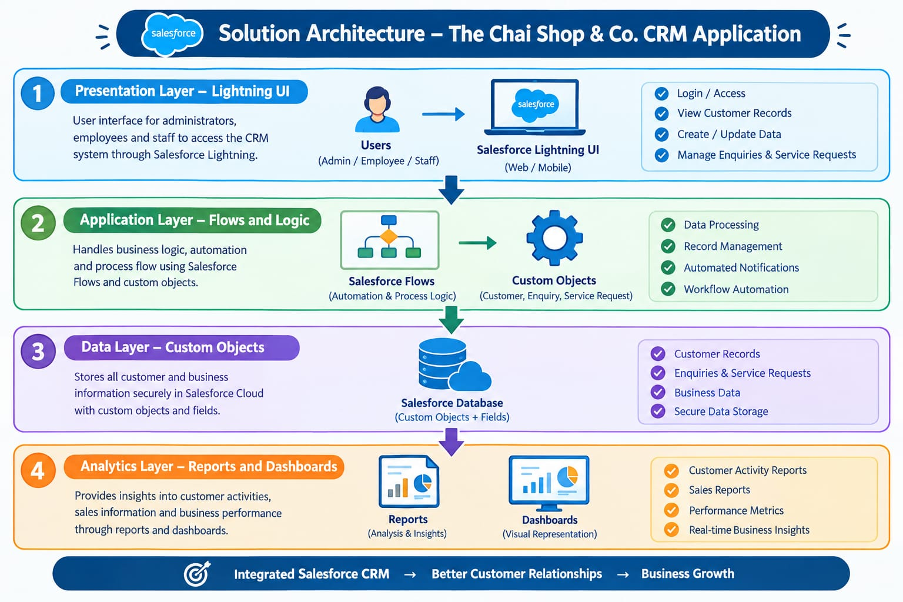

5. PROJECT PLANNING & SCHEDULING

5.1 Project Planning
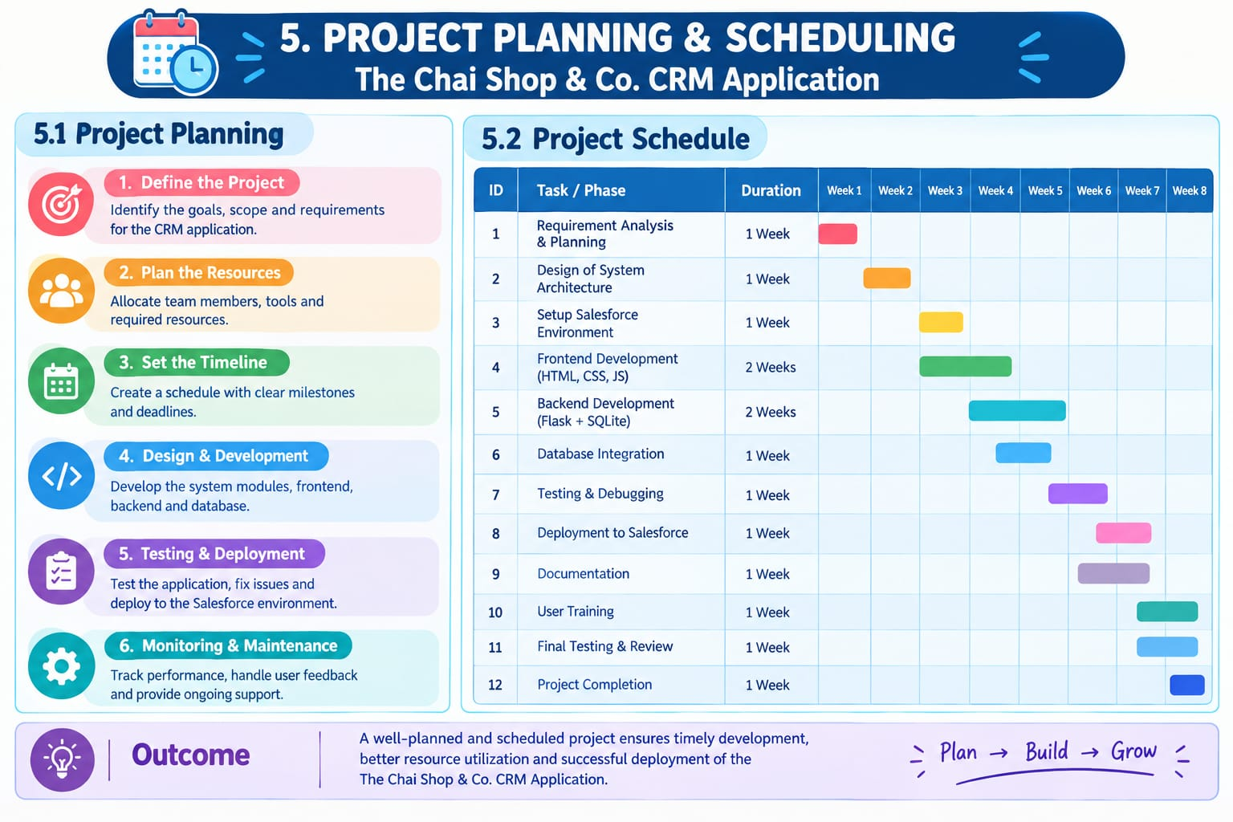

● Customer and account fields were configured to maintain customer information and preferences consistently.

● Page layouts and user access were configured for the Salesforce Administrator and employees based on their responsibilities.

● Validation rules were implemented to reduce incorrect or incomplete customer information.

● Salesforce automation and notifications were used to manage customer interactions and business activities efficiently.

● Reports and dashboards were created to monitor customer records, sales activities, and business performance.

● Customer records were regularly reviewed and updated to maintain accurate and organized information.

● The CRM application was implemented systematically to help The Chai Shop & Co. manage its growing customer base efficiently.

Product Backlog, Sprint Schedule, and Estimation (4 Marks)
Use the below template to create product backlog and sprint schedule

Sprint | Functional Requirement | User story Number | User story/task | Story point | Priority | Team Member
Sprint-1 | Developer Setup | USN-1 | As an admin, I want to set up the Salesforce CRM application so that I can configure and manage The Chai Shop & Co. business processes. | 1 | High | Member 1
Sprint-1 | Data Modeling | USN-2 | As an admin, I want to create Customer, Order, and Business-related objects so that customer and order information can be stored systematically. | 3 | High | Member 2
Sprint-2 | Data Modeling | USN-3 | As a user, I want separate tabs for customers, orders, and other CRM records so that I can easily access and manage business information. | 3 | High | Member 3
Sprint-2 | Data Modeling | USN-4 | As a manager, I want a dedicated Lightning App for The Chai Shop & Co. so that CRM activities can be accessed from one place. | 3 | High | Member 4
Sprint-2 | Data Modeling | USN-5 | As a user, I want customized page layouts for different record types so that only relevant customer and order information is displayed. | 5 | Medium | Member1
Sprint-2 | Data Modeling | USN-6 | As a manager, I want to categorize customer records based on their business relationship and preferences so that customers can be managed efficiently. | 5 | High | Member 2
Sprint-3 | Automatiom | USN-7 | As a system, I want to validate customer and order information so that incorrect or incomplete data entries are prevented. | 3 | High | Member 4
Sprint-4 | Automatiom | USN-8 | As a system, I want to automate customer notifications and follow-up activities so that customers receive timely updates about their orders and enquiries. | 5 | High | Member 2
Sprint-5 | Reports | USN-9 | As a manager, I want reports for customers, orders, and sales so that I can monitor business performance and make informed decisions. | 4 | High | Member 3
Sprint-6 | Dashboards | USN-10 | As a manager, I want a dashboard showing customer, order, and sales information so that I can quickly understand the overall performance of The Chai Shop & Co. | 4 | Medium | Member 4
project Tracker, Velocity & Burndown Chart: (4 Marks)

6. Project Development Phase:

Project Flow
Milestone 1 : Creation of developer account
Milestone 2 : Object Creation

Milestone 3 : Tabs

Milestone 4 : The Lightning App

Milestone 5 : Global Picklist

Milestone 6 : Fields and Relationships

Milestone 7 : Creation of Page Layout

Milestone 8 : Creation of Record Types

Milestone 9 : Validation rules

Milestone 10 : Email Templates

Milestone 11 : Flows

Milestone 12 : Reports and Dashboards

Milestone 13 : Conclusion

What you'll learn

What you'll learn
- Real Time Salesforce Project
- Standard and Custom objects
- Picklist Value sets
- Types of Fields & their relationships.
- Page Layouts
- Record Types
- Validation Rules
- Email Templates
- Flows
- Reports and Dashboards.

Implementation
Milestone 1 - Salesforce developer account creation :

Activity 1: Creating Developer Account:

Creating a developer org in salesforce.
1. Go to https://developer.salesforce.com/signup 2. On the sign up form, enter the following details :

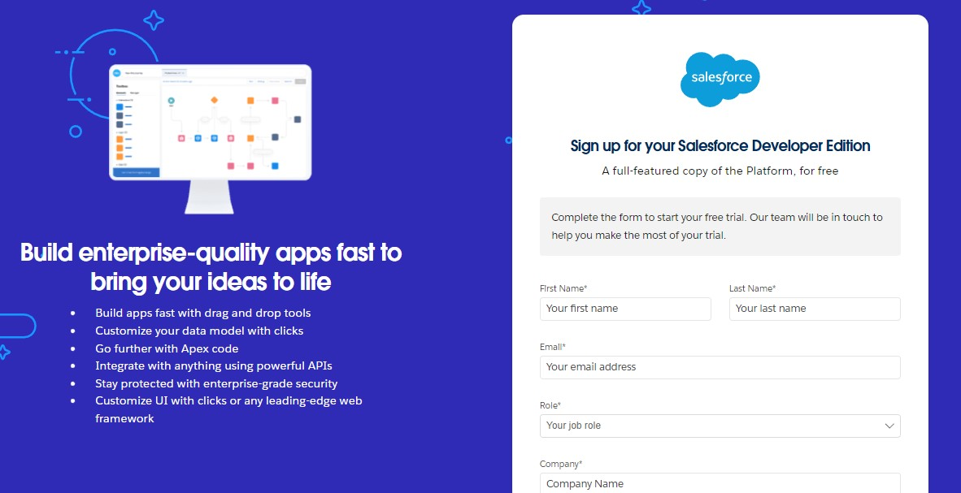

- First name & Last name
- Email
- Role : Developer
- Company : College or Company Name
- County : India
- Postal Code : pin code
- Username : should be a combination of your name and company
This need not be an actual email id, you can give anything in that format :
username@organization.com
Click on sign me up after filling these.

Activity 2: Account Activation :

- Go to the inbox of the email that you used while signing up. Click on the verify account to activate your account. The email may take 5-10mins.

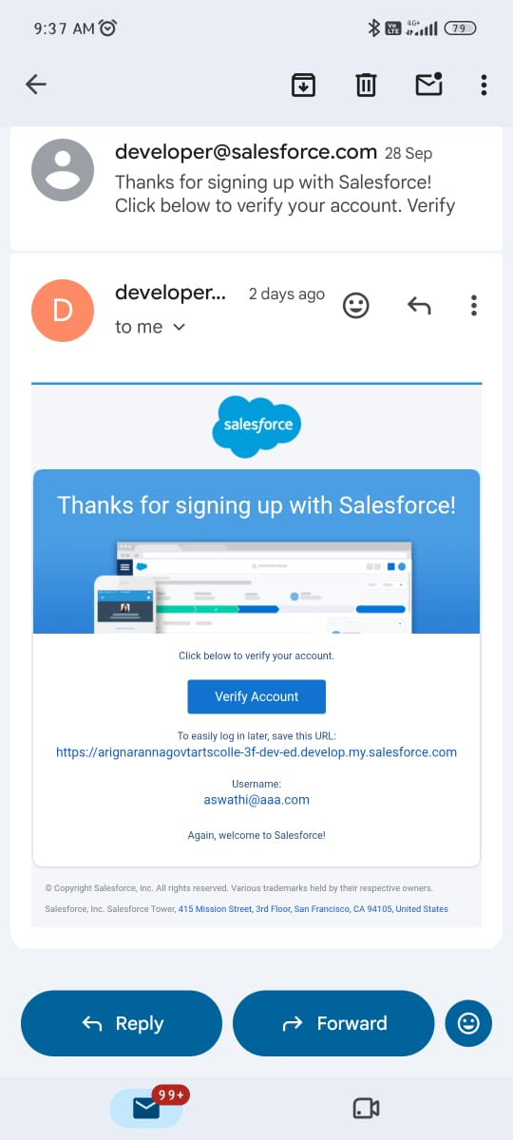
- Click on Verify Account.
- Give a password and answer a security question and click on change password.

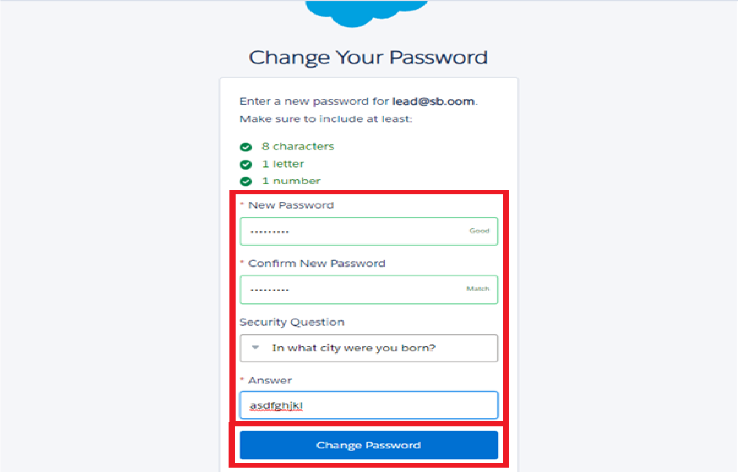

- Then you will redirect to your salesforce setup page.

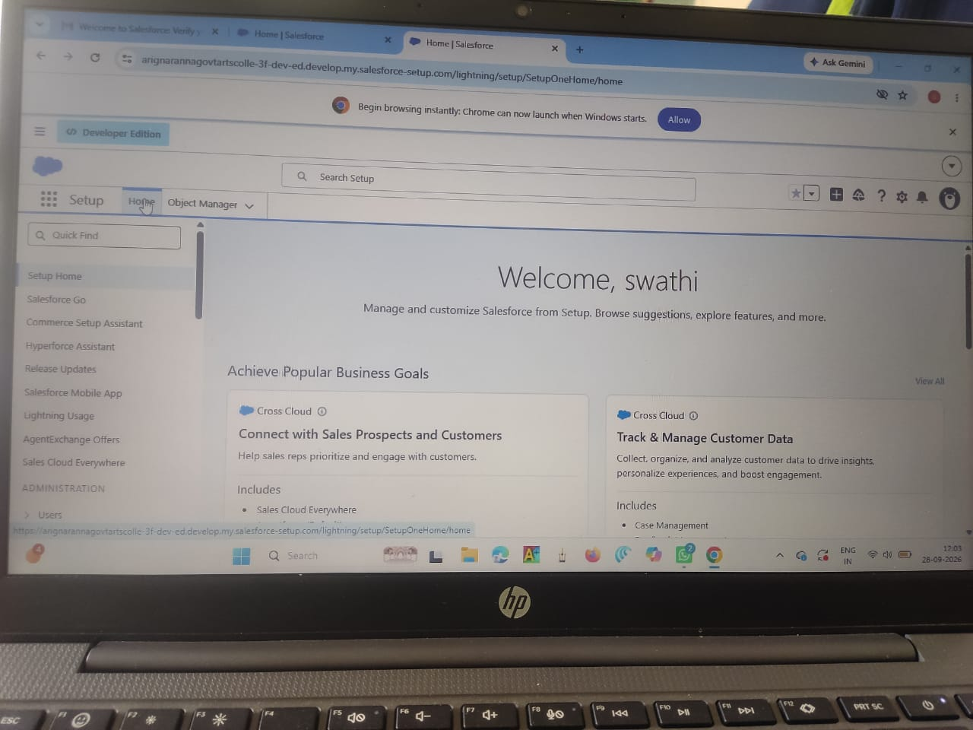

Milestone 2 - Objects

- In your Salesforce org, click gear icon on the top left and select Setup to open Setup.

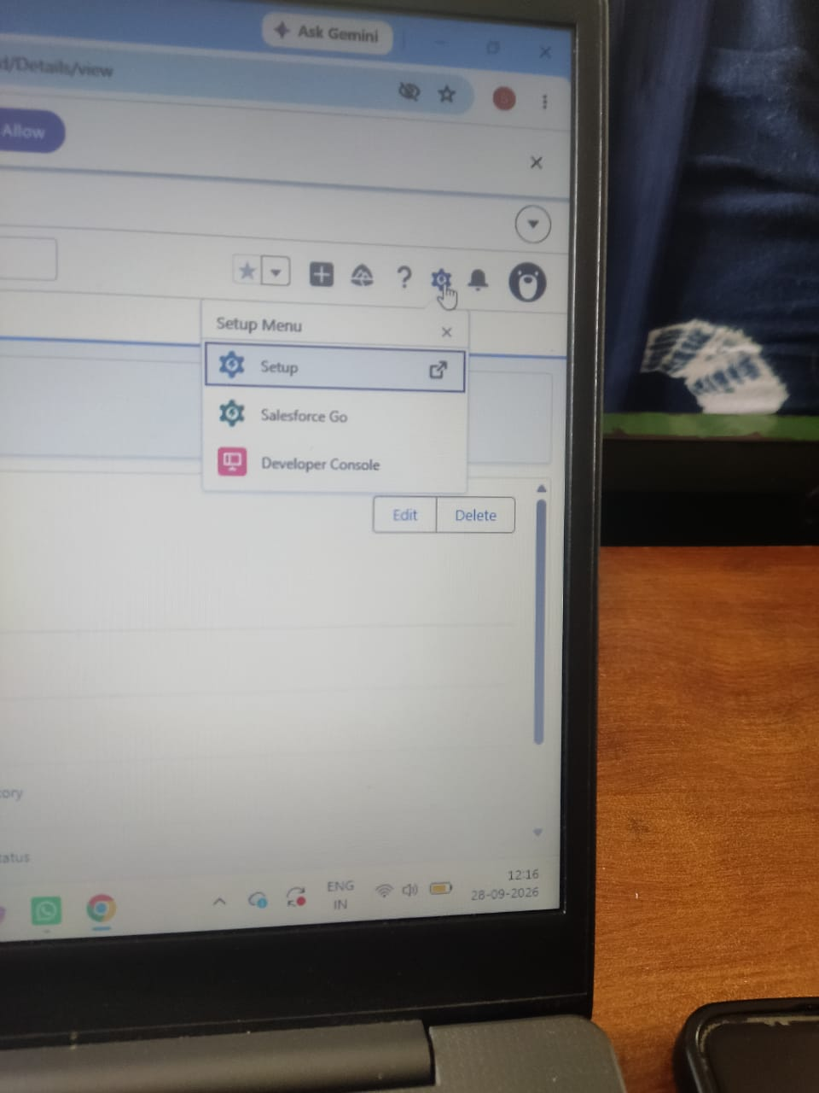

- Click the Object Manager tab. If you don’t see it, enter Object Manager in the Quick Find box.
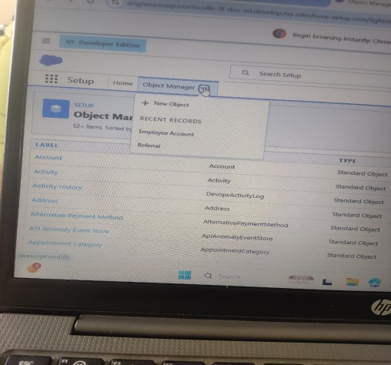

- On the Object Manager page, click Create | Custom Object.

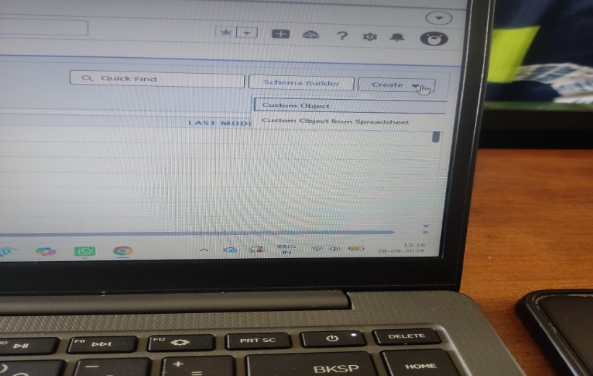

Activity 1 : Employer Account Object

1. From the setup page → Click on Object Manager → Click on Create → Click on Custom Object.
- Label : Employer Account
- Plural Label : Employer Accounts
- Enter Record Name Label and Format
Record Name : Employer Account Name
Data Type : Text
- In Optional features : check the boxes for Allow Reports | Allow Activities | Track Field History.
- Search Status : check the box for Allow Search.
- Save

Activity 2 : Customer Account Object

1. From the setup page → Click on Object Manager → Click on Create → Click on Custom Object.
- Label : Customer Account
- Plural Label : Customer Accounts
- Enter Record Name Label and Format
Record Name : Customer Account Name
Data Type : Text
- In Optional features : check the boxes for Allow Reports | Allow Activities | Track Field History.
- Search Status : check the box for Allow Search.
- Save

Activity 3 : Enterprise Account Object

1. From the setup page → Click on Object Manager → Click on Create → Click on Custom Object.
- Label : Enterprise Account
- Plural Label : Enterprise Accounts
- Enter Record Name Label and Format
Record Name : Enterprise Account Name Data Type : Text
- In Optional features : check the boxes for Allow Reports | Allow Activities | Track Field History.
- Search Status : check the box for Allow Search.
- Save

Milestone 3 - Tabs

Activity 1 : Custom tabs creation

- Go to setup page → type Tabs in Quick Find bar → click on tabs → New (under custom object tab)

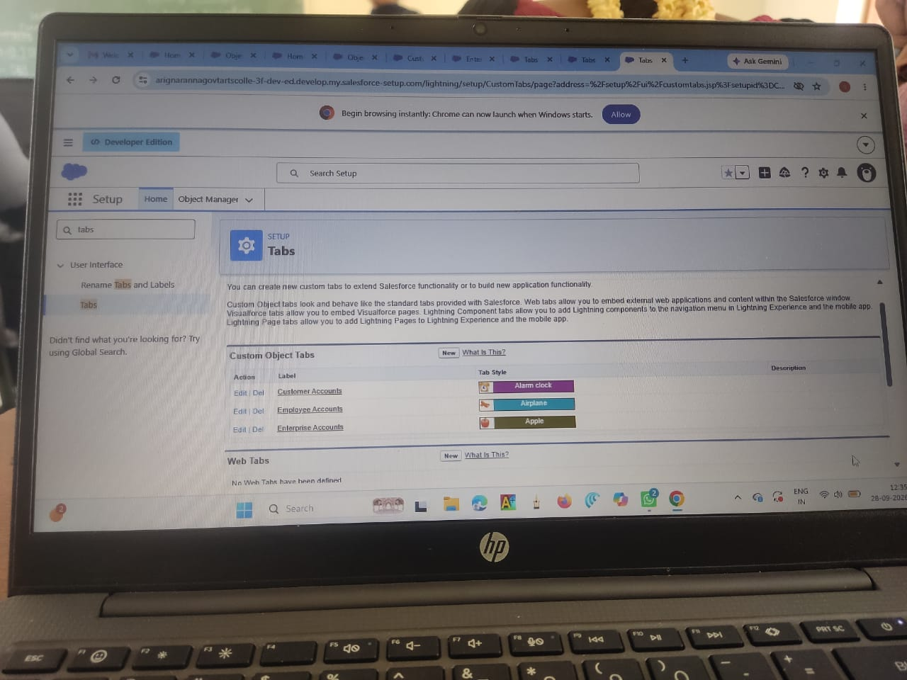
- Select Object(Employer Accounts) → Select the tab style → Next (Add to profiles page) keep it as default → Next (Add to Custom App) uncheck the include tab .
- Make sure that the Append tab to users' existing personal customizations is checked.
- Click save.
- Repeat the same steps for Customer Accounts and Enterprise Accounts.

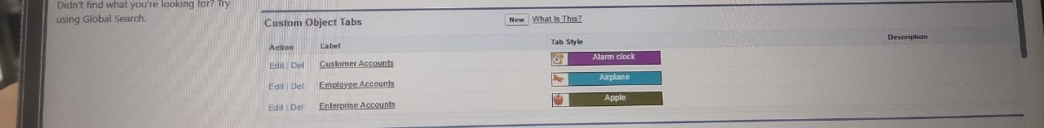

Milestone 4 - The Lightning App

Activity 1 : Create a lightning app

- Go to setup page → search “app manager” in quick find → select “app manager”
→ click on New lightning App.

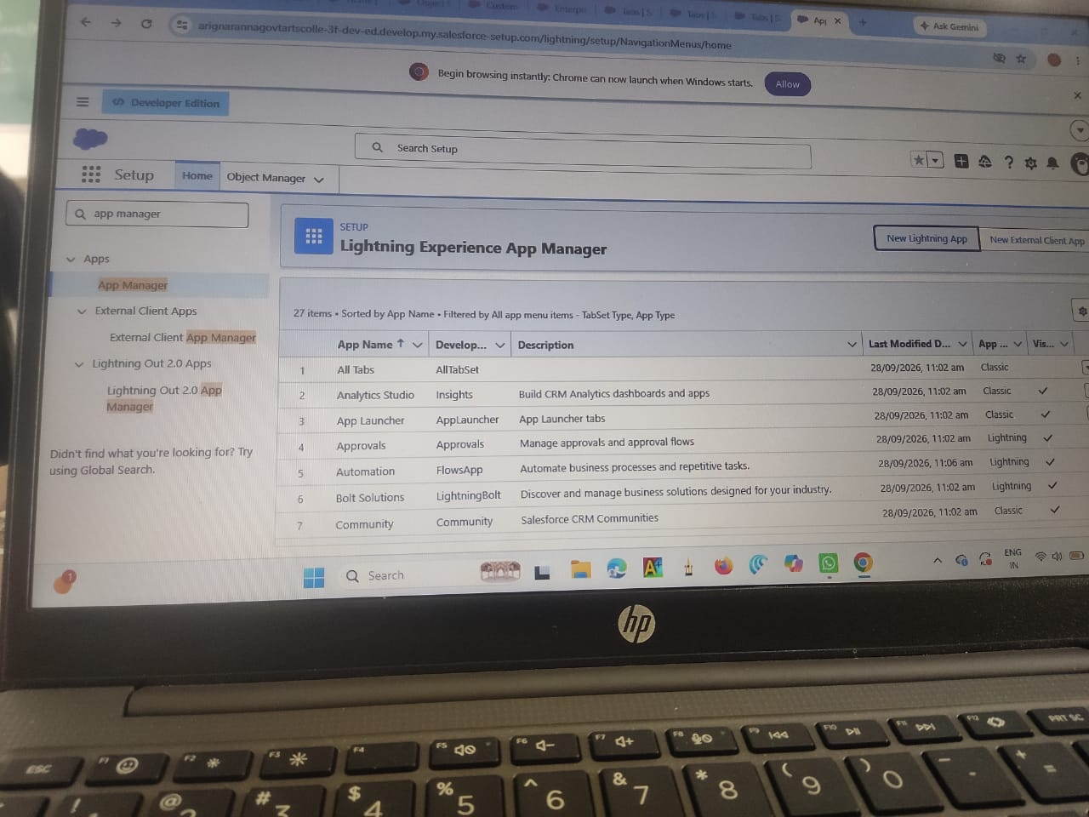

- Fill the app name in app details and branding as follow
App Name : TheChaiShop&Co
Developer Name : Auto Populates
Add image optional (if you want to give any image you can otherwise not mandatory) - Add Primary color Hex or leave it to default. Then click Next.

- In App options
Navigation style : Standard navigation
Setup experience : setup
Supporters form factors : Desktop and phone
Then click Next

- In Utility items
Utility Bar alignment : Default Then click Next.

- Navigation items
Select the created Custom Objects and required standard objects
● Customer Accounts
Employer Accounts
Enterprise Accounts
Reports
Dashboards

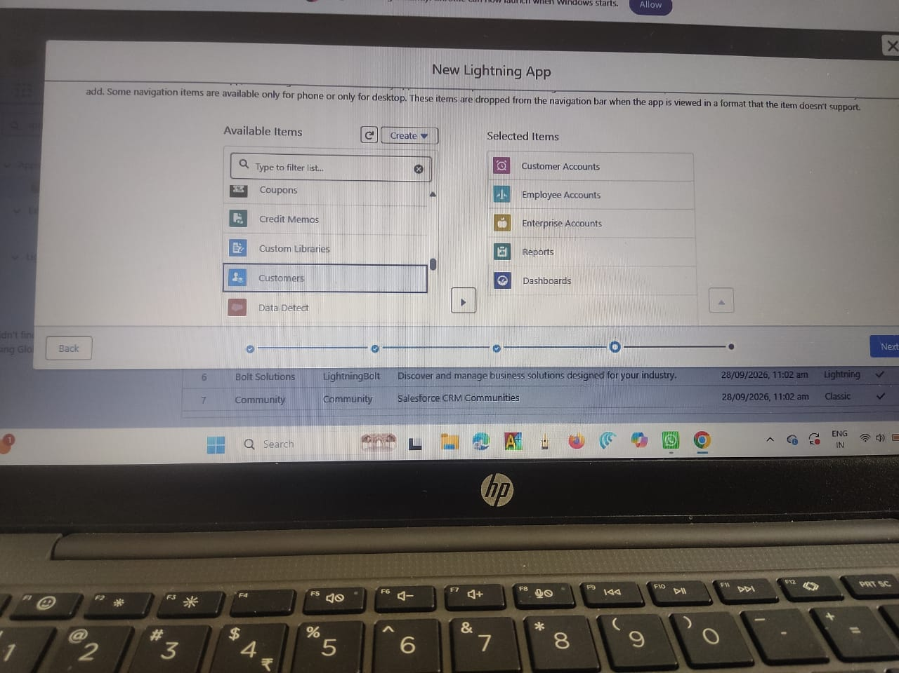
- To Add User Profiles : System Administrator

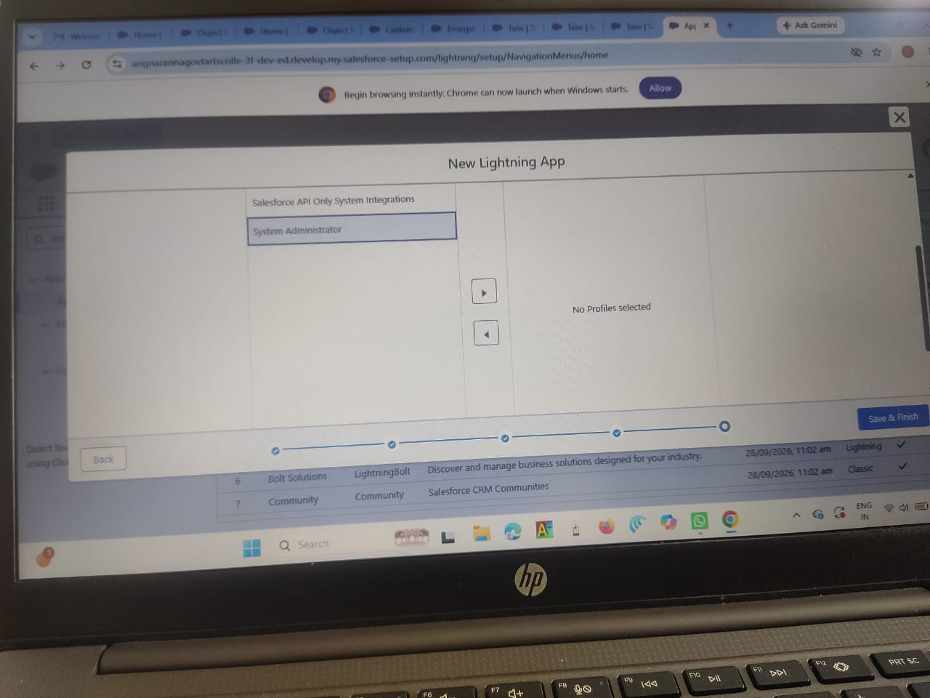
- Click Save & Finish.

Milestone 5 : Global Picklist

Activity 1 : Create Global PIcklist

- In Quick find box search for : Picklist value sets and click New.

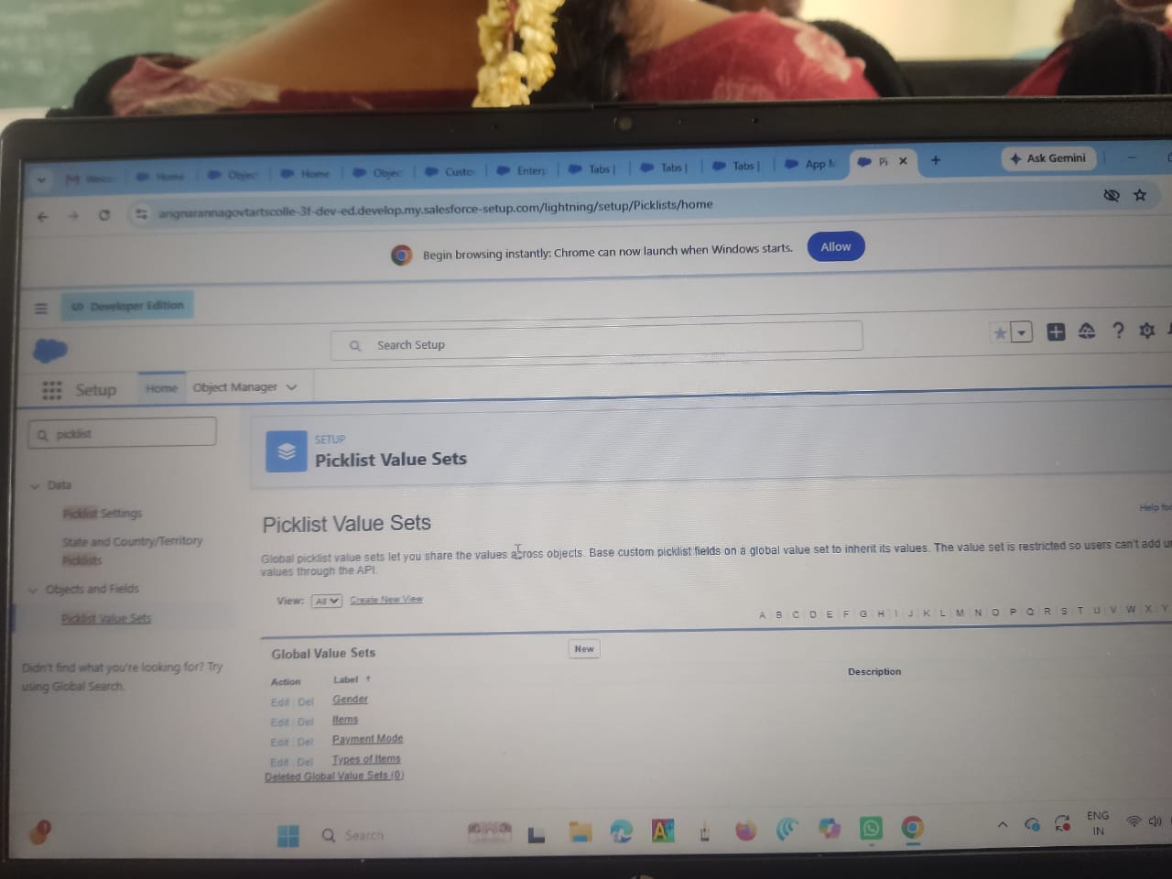

  - Label : Gender
Name : Auto Populates
Values : Male
Female
Others Click Save & New.
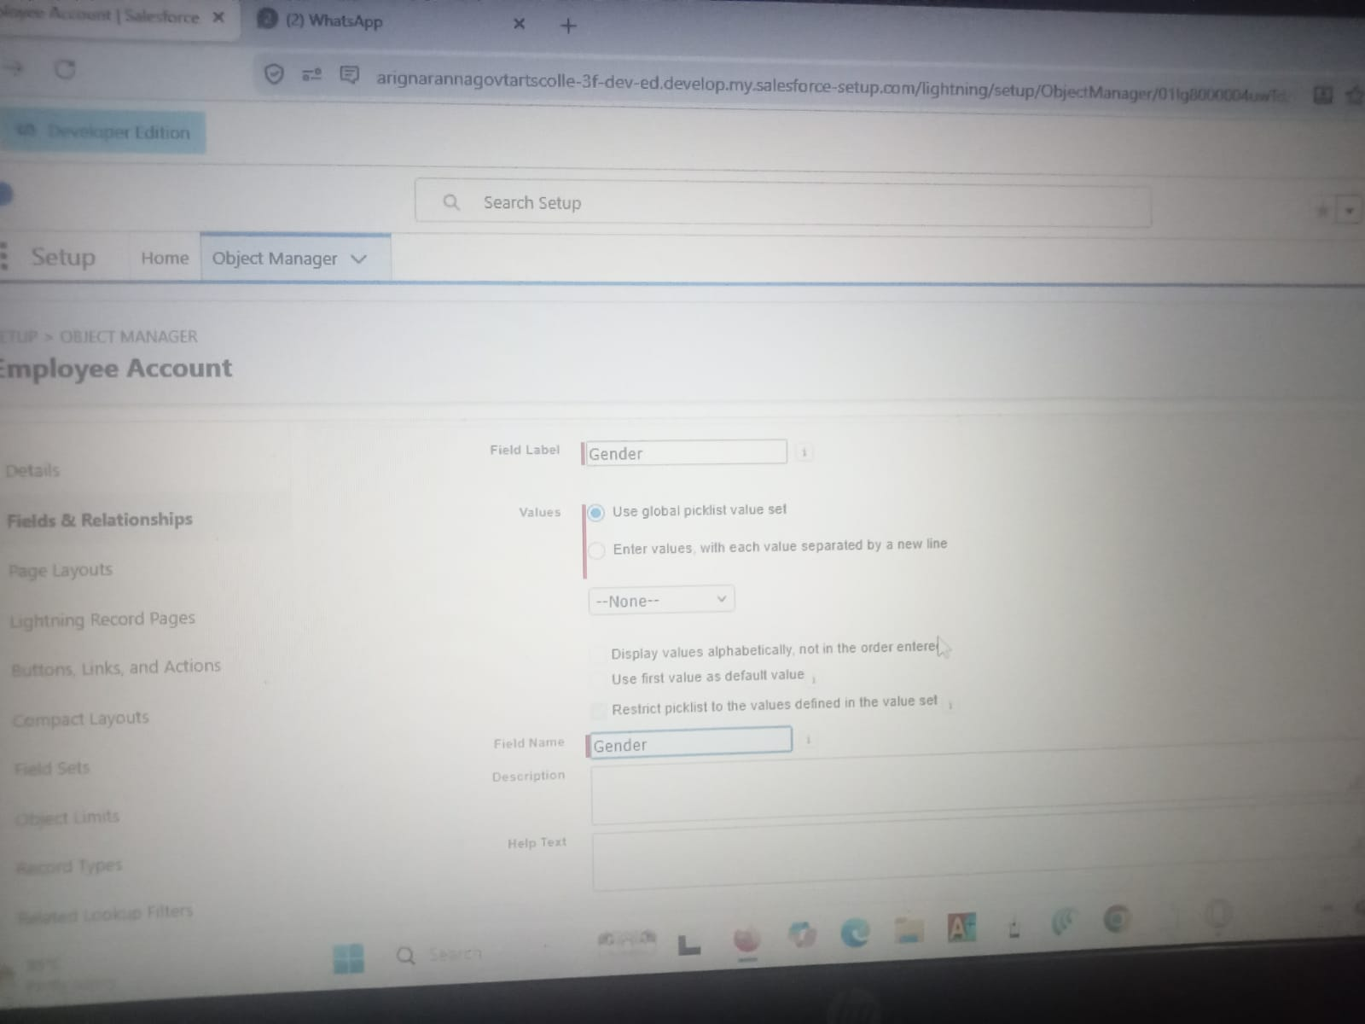

- Create three more Global picklists following the same steps.
  - Label : Items Name : Auto populates
Values : Platinum Tea Powder
Double Delight Tea Powder
Super Dust Tea Powder
Osmania Biscuits (Value Pack)
Osmania Biscuits (Premium Pack)
Dry Fruit Biscuits
Fruit Biscuits
Salt Biscuits
Multigrain Biscuits
Ragi Biscuits
Double Choco Chip Cookies
Butter Almond Cookies
Melting Moments Cookies
Honey Oats Cookies
Delight Box
Signature Box
Assorted Box
Click Save & New.

- Label : Payment Mode
Name : Auto populates
Values : Gpay
PhonePe
Paytm
Credit or Debit card Cash.
Click Save & New.

- Label : Type of Items
Name : Auto populates
Values : Tea powder
Cookies Gift Hampers
Click Save.

Milestone 6 : Fields & Relationships

Activity 1 : Create Custom fields for Employer Account

- In your Salesforce org, click gear icon on the top left and select Setup to open Setup.
- Click the Object Manager tab. If you don’t see it, enter Object Manager in the Quick Find box.
- From the object manager page, In the Quick Find box, Search for the custom object you just created : Employer Account
- From the sidebar, click Fields & Relationships. Notice that there are already some fields there. Those are the standard fields.
- Click New to create a custom field. Tip: Before creating a new field, do a quick search to make sure a similar one doesn’t already exist.

- Next, choose a data type as Text. Choosing a data type helps you format the field input.

- Click on next.

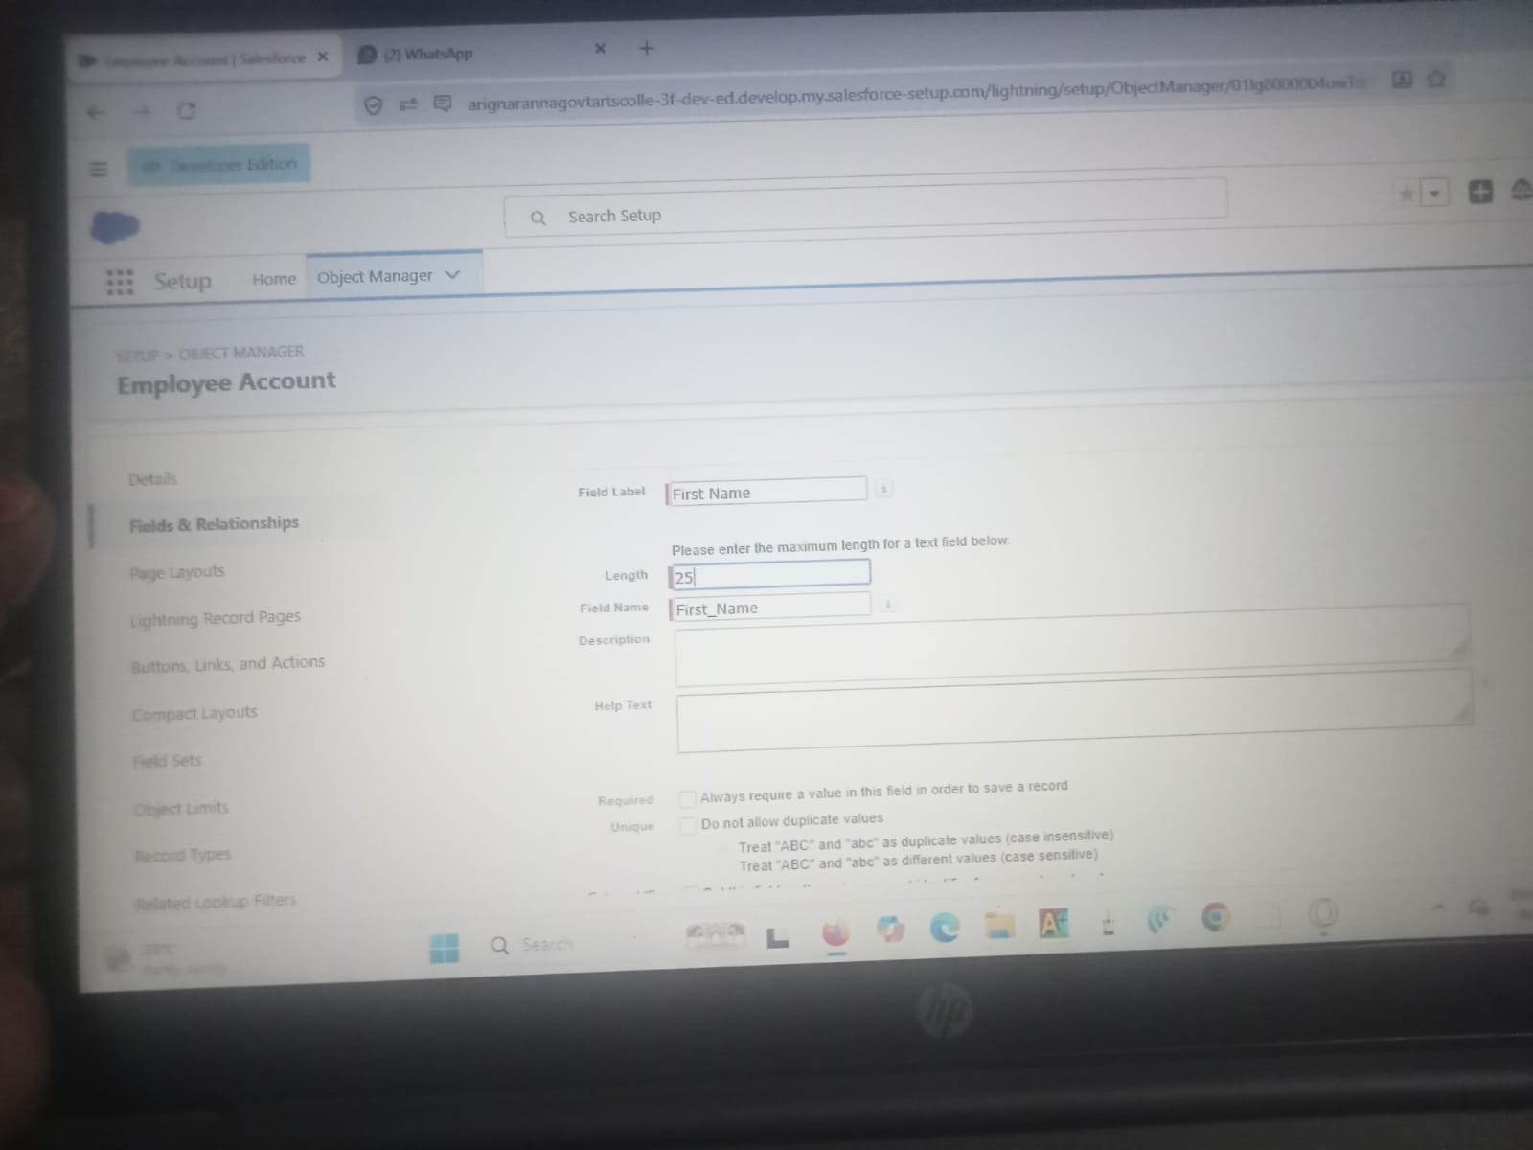

- Data Type : Text
Field Label: First Name
Field Name : Auto Populates
Length : 25
Required : Check the box
Click on Next → Next → Save and new.

- Repeat the Same steps for remaining fields

  - Data Type : Text
Field Label: Last Name
Field Name : Auto Populates
Length : 25
Required : Check the box
Click on Next → Next → Save and new.

  - Data Type : PickList
Field Label: Gender
Values : Use Global Picklist value set and select Gender from the dropdown menu.
Field Name : Auto Populates. Required : Check the box
Click on Next → Next → Save and new.

  - Data Type : Phone
Field Label : Phone Number
Field Name : Auto Populates Required : Check the box
Click on Next → Next → Save and new.

  - Data Type : Email
Field Label : Email ID
Field Name : Auto Populates Required : Check the box
Click on Next → Next → Save and new.

  - Data Type : Date
Field Label : Date of Birth
Field Name : Auto Populates Required : check the box
Click on Next → Next → Save and new.

  - Data Type : Text
Field Label : Aadhar Number
Field Name : Auto Populates
Length : 12
Click on Next → Next → Save and new.

  - Data Type : Text
Field Label : PAN Details
Field Name : PAN_Details
Length : 10
Click on Next → Next → Save and new.

  - Data Type : Picklist
Field Label : Designation
Field Name : Auto Populates
Value : Enter value, with each value separated by a new line.
Manager
Finance and Accounting
Kitchen Staff
Cashier
Servers
Click on Next → Next → Save and new.

  - Data Type : Currency
Field Label : Salary Field Name : Auto Populates Click on Next → Next → Save.

Activity 2: Create Custom fields for Customer Account

- Data Type : Text
Field Label: First Name
Field Name : Auto Populates
Length : 25
Required : Check the box
Click on Next → Next → Save and new.

- Data Type : Text
Field Label: Last Name
Field Name : Auto Populates
Length : 25
Required : Check the box
Click on Next → Next → Save and new.

- Data Type : PickList
Field Label: Gender
Values : Use Global Picklist value set and select Gender from the dropdown menu.
Field Name : Auto Populates. Required : Check the box
Click on Next → Next → Save and new.

- Data Type : Phone
Field Label : Phone Number
Field Name : Auto Populates Required : Check the box
Click on Next → Next → Save and new.

- Data Type : Date
Field Label : Date of Birth
Field Name : Auto Populates Required : check the box
Click on Next → Next → Save and new.

- Data Type : Formula
Field Label : Date of Birthday is today ?
Field Name : Auto Populates Formula Return : Checkbox Formula :
IF(
AND(
DAY( TODAY() ) = DAY( Date_of_Birth__c ) ,
MONTH ( TODAY()) = MONTH( Date_of_Birth__c )),
TRUE,
FALSE)
Click on Next → Next → Save and new.

- Data Type : Email
Field Label : Email ID
Field Name : Auto Populates Required : Check the box
Click on Next → Next → Save and new.

- Date Type : Text
Field Label : Address
Field Name : Auto Populates
Length : 125
Click on Next → Next → Save and new.

- Date Type : Multi Select Picklist
Field Label : Type of Items
Values : Use Global Picklist value set and select Type of Items from the dropdown menu.
Field Name : Auto Populates. Required : Check the box
Click on Next → Next → Save and new.

- Date Type : Multi Select Picklist
Field Label : Products purchased
Values : Use Global Picklist value set and select Items from the dropdown menu.
Field Name : Auto Populates. Required : Check the box
Click on Next → Next → Save and new.

- Date Type : Multi Select Picklist
Field Label : Chai
Value : Enter value, with each value separated by a new line.
TheChaiShop&Co Special Tea
Single Tea
Masala Tea
Lemon Tea
Ginger Tea
Green Tea
Sugar Free Tea
Click on Next → Next → Save and new.

- Data Type : Picklist
Field Label : Payment Mode
Values : Use Global Picklist value set and select Payment Mode from the dropdown menu.
Field Name : Auto Populates. Required : Check the box
Click on Next → Next → Save and new.

- Data Type : Lookup Relationship
Related To : Employer Account
Field Label : Associated Employer Field Name : Auto Populates
Click on Next → Next → Save and new.

- Data Type : Formula Field Label : Order Quantity
Field Name : Auto Populates
Formula Return : Number

Enter Formula = Quantity (Number) =
IF(INCLUDES( Products_Purchased__c , "Platinum Tea Powder"), 1, 0 ) +
IF(INCLUDES( Products_Purchased__c , "Double Delight Tea Powder"), 1, 0 ) +
IF( INCLUDES( Products_Purchased__c , "Super Dust Tea Powder") , 1, 0) +
IF(INCLUDES( Products_Purchased__c , "Osmania Biscuits (Value Pack)"), 1, 0 ) +
IF(INCLUDES( Products_Purchased__c , "Osmania Biscuits (Premium Pack)"), 1, 0 ) +
IF( INCLUDES( Products_Purchased__c , "Dry Fruit Biscuits") , 1, 0) +
IF(INCLUDES( Products_Purchased__c , "Fruit Biscuits"), 1, 0 ) +
IF(INCLUDES( Products_Purchased__c , "Salt Biscuits"), 1, 0 ) +
IF(INCLUDES( Products_Purchased__c , "Multigrain Biscuits"), 1, 0 ) +
IF(INCLUDES( Products_Purchased__c , "Ragi Biscuits"), 1, 0 ) +
IF( INCLUDES( Products_Purchased__c ,"Double Choco chip Cookies") , 1, 0) +
IF(INCLUDES( Products_Purchased__c , "Butter Almond Cookies"), 1, 0 ) +
IF(INCLUDES( Products_Purchased__c , "Melting Moments Cookies"), 1, 0 ) +
IF( INCLUDES( Products_Purchased__c , "Honey Oats Cookies") , 1, 0) +
IF(INCLUDES( Products_Purchased__c , "Delight Box"), 1, 0 ) +
IF(INCLUDES( Products_Purchased__c , "Signature Box"), 1, 0 ) +
IF( INCLUDES( Products_Purchased__c , "Assorted Pack") , 1, 0) +
IF(INCLUDES( Chai__c , "TheChaiShop&Co Special Tea"), 1, 0) +
IF(INCLUDES( Chai__c , "Single Tea"), 1, 0) +
IF(INCLUDES( Chai__c , "Masala Tea"), 1, 0) +
IF(INCLUDES( Chai__c , "Lemon Tea"), 1, 0) +
IF(INCLUDES( Chai__c , "Ginger Tea"), 1, 0) +
IF(INCLUDES( Chai__c , "Green Tea"), 1, 0) +
IF(INCLUDES( Chai__c , "Sugar Free Tea"), 1, 0)

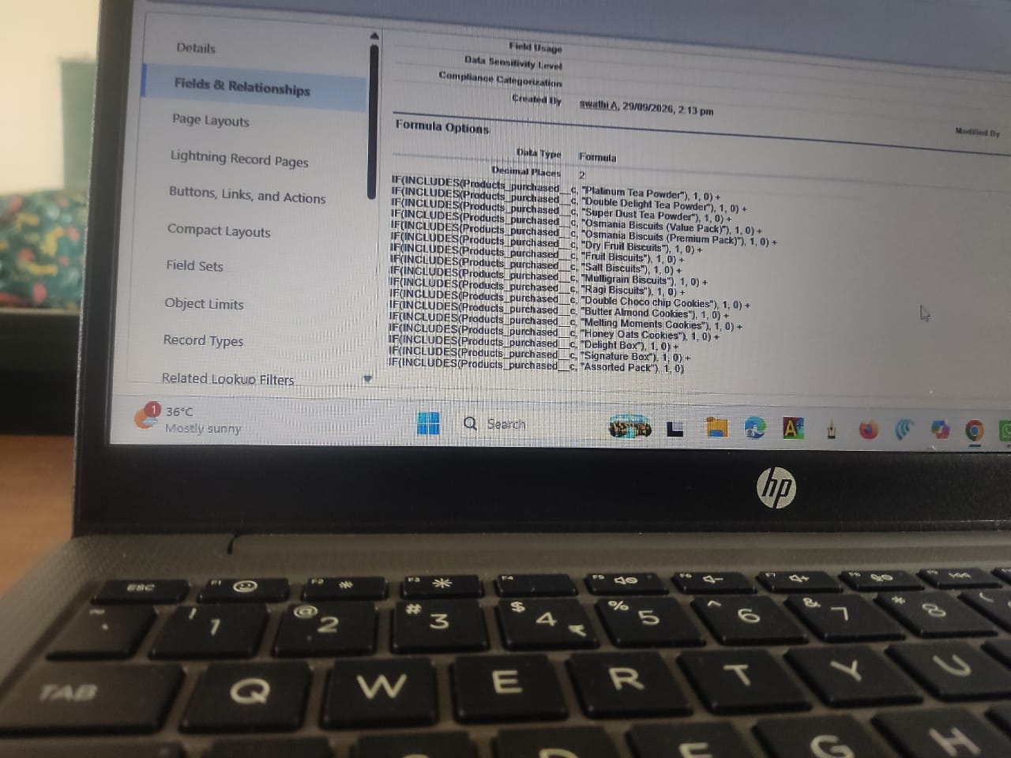
Click on Next → Next → Save and new.

15. Data Type : Formula
Field Label : Total Bill
Field Name : Auto Populates
Formula Return : Number
Enter Formula = Quantity (Number) =
IF(INCLUDES( Products_Purchased__c , "Platinum Tea Powder"), 175, 0 ) +
IF(INCLUDES( Products_Purchased__c , "Double Delight Tea Powder"), 150, 0 ) +
IF( INCLUDES( Products_Purchased__c , "Super Dust Tea Powder") , 125, 0) +
IF(INCLUDES( Products_Purchased__c , "Osmania Biscuits (Value Pack)"), 50, 0 ) +
IF(INCLUDES( Products_Purchased__c , "Osmania Biscuits (Premium Pack)"), 80, 0 ) +
IF( INCLUDES( Products_Purchased__c , "Dry Fruit Biscuits") , 110, 0) +
IF(INCLUDES( Products_Purchased__c , "Fruit Biscuits"), 160, 0 ) +
IF(INCLUDES( Products_Purchased__c , "Salt Biscuits"), 110, 0 ) +
IF(INCLUDES( Products_Purchased__c , "Multigrain Biscuits"), 170, 0 ) +
IF(INCLUDES( Products_Purchased__c , "Ragi Biscuits"), 190, 0 ) +
IF( INCLUDES( Products_Purchased__c ,"Double Choco chip Cookies") , 200, 0) +
IF(INCLUDES( Products_Purchased__c , "Butter Almond Cookies"), 110, 0 ) +
IF(INCLUDES( Products_Purchased__c , "Melting Moments Cookies"), 150, 0 ) +
IF( INCLUDES( Products_Purchased__c , "Honey Oats Cookies") , 160, 0) +
IF(INCLUDES( Products_Purchased__c , "Delight Box"), 850, 0 ) +
IF(INCLUDES( Products_Purchased__c , "Signature Box"), 1500, 0 ) +
IF( INCLUDES( Products_Purchased__c , "Assorted Pack") , 600, 0) +
IF(INCLUDES( Chai__c , "TheChaiShop&Co Special Tea"), 70, 0) +
IF(INCLUDES( Chai__c , "Single Tea"), 50, 0) +
IF(INCLUDES( Chai__c , "Masala Tea"), 60, 0) +
IF(INCLUDES( Chai__c , "Lemon Tea"), 40, 0) +
IF(INCLUDES( Chai__c , "Ginger Tea"),55, 0) +
IF(INCLUDES( Chai__c , "Green Tea"), 45, 0) +
IF(INCLUDES( Chai__c , "Sugar Free Tea"), 55, 0)

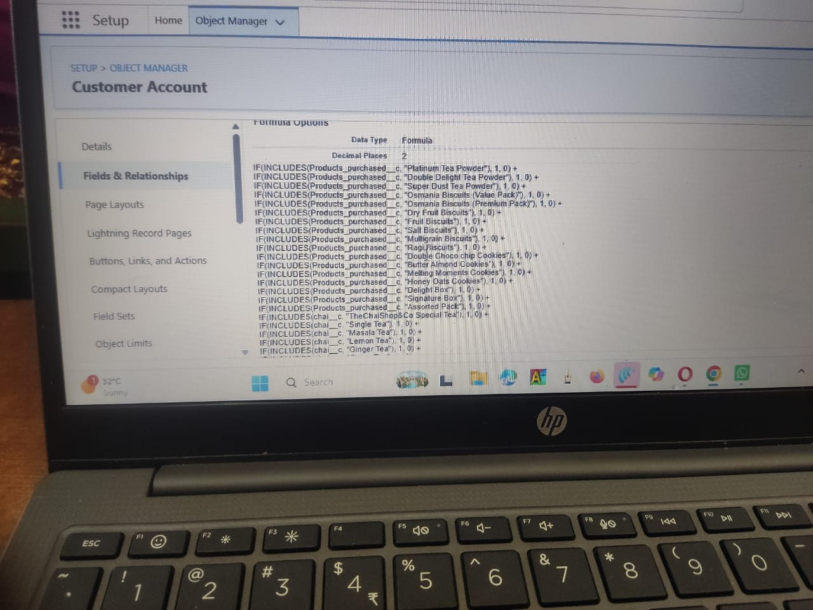
Click on Next → Next → Save.

Activity 3: Create Custom fields for Enterprise Account

- Data Type : Text
Field Label: Enterprise Name
Field Name : Auto Populates
Length : 25
Required : Check the box
Click on Next → Next → Save and new.

- Data Type : Phone
Field Label : Phone Number
Field Name : Auto Populates Required : Check the box
Click on Next → Next → Save and new.

- Data Type : Email Field Label : Email ID
Field Name : Auto Populates Required : Check the box
Click on Next → Next → Save and new.

- Date Type : Text
Field Label : Address
Field Name : Auto Populates
Length : 125
Click on Next → Next → Save and new.

- Date Type : Multi Select Picklist
Field Label : Type of Items
Values : Use Global Picklist value set and select Type of Items from the dropdown menu.
Field Name : Auto Populates. Required : Check the box
Click on Next → Next → Save and new.

- Date Type : Multi Select Picklist
Field Label : Products purchased
Values : Use Global Picklist value set and select Items from the dropdown menu.
Field Name : Auto Populates. Required : Check the box
Click on Next → Next → Save and new.

- Data Type : Lookup Relationship
Related To : Employer Account
Field Label : Associated Employer Field Name : Auto Populates
Click on Next → Next → Save and new.

- Data Type : Formula
Field Label : Order Quantity
Field Name : Auto Populates
Formula Return : Number
Enter Formula = Quantity (Number) =
IF(INCLUDES( Products_Purchased__c , "Platinum Tea Powder"), 1, 0 ) +
IF(INCLUDES( Products_Purchased__c , "Double Delight Tea Powder"), 1, 0 ) +
IF( INCLUDES( Products_Purchased__c , "Super Dust Tea Powder") , 1, 0) +
IF(INCLUDES( Products_Purchased__c , "Osmania Biscuits (Value Pack)"), 1, 0 ) +
IF(INCLUDES( Products_Purchased__c , "Osmania Biscuits (Premium Pack)"), 1, 0 ) +
IF( INCLUDES( Products_Purchased__c , "Dry Fruit Biscuits") , 1, 0) +
IF(INCLUDES( Products_Purchased__c , "Fruit Biscuits"), 1, 0 ) +
IF(INCLUDES( Products_Purchased__c , "Salt Biscuits"), 1, 0 ) +
IF(INCLUDES( Products_Purchased__c , "Multigrain Biscuits"), 1, 0 ) +
IF(INCLUDES( Products_Purchased__c , "Ragi Biscuits"), 1, 0 ) +
IF( INCLUDES( Products_Purchased__c ,"Double Choco chip Cookies") , 1, 0) +
IF(INCLUDES( Products_Purchased__c , "Butter Almond Cookies"), 1, 0 ) +
IF(INCLUDES( Products_Purchased__c , "Melting Moments Cookies"), 1, 0 ) +
IF( INCLUDES( Products_Purchased__c , "Honey Oats Cookies") , 1, 0) +
IF(INCLUDES( Products_Purchased__c , "Delight Box"), 1, 0 ) +
IF(INCLUDES( Products_Purchased__c , "Signature Box"), 1, 0 ) + IF( INCLUDES( Products_Purchased__c , "Assorted Pack") , 1, 0)
Click on Next → Next → Save and new.

9. Data Type : Formula Field Label : Total Bill
Field Name : Auto Populates
Formula Return : Number
Enter Formula = Quantity (Number) =
IF(INCLUDES( Products_Purchased__c , "Platinum Tea Powder"), 175, 0 ) +
IF(INCLUDES( Products_Purchased__c , "Double Delight Tea Powder"), 150, 0 ) +
IF( INCLUDES( Products_Purchased__c , "Super Dust Tea Powder") , 125, 0) +
IF(INCLUDES( Products_Purchased__c , "Osmania Biscuits (Value Pack)"), 50, 0 ) +
IF(INCLUDES( Products_Purchased__c , "Osmania Biscuits (Premium Pack)"), 80, 0 ) +
IF( INCLUDES( Products_Purchased__c , "Dry Fruit Biscuits") , 110, 0) +
IF(INCLUDES( Products_Purchased__c , "Fruit Biscuits"), 160, 0 ) +
IF(INCLUDES( Products_Purchased__c , "Salt Biscuits"), 110, 0 ) +
IF(INCLUDES( Products_Purchased__c , "Multigrain Biscuits"), 170, 0 ) +
IF(INCLUDES( Products_Purchased__c , "Ragi Biscuits"), 190, 0 ) +
IF( INCLUDES( Products_Purchased__c ,"Double Choco chip Cookies") , 200, 0) +
IF(INCLUDES( Products_Purchased__c , "Butter Almond Cookies"), 110, 0 ) +
IF(INCLUDES( Products_Purchased__c , "Melting Moments Cookies"), 150, 0 ) +
IF( INCLUDES( Products_Purchased__c , "Honey Oats Cookies") , 160, 0) +
IF(INCLUDES( Products_Purchased__c , "Delight Box"), 850, 0 ) +
IF(INCLUDES( Products_Purchased__c , "Signature Box"), 1500, 0 ) +
IF( INCLUDES( Products_Purchased__c , "Assorted Pack") , 600, 0)
10. Data Type : Picklist
Field Label : Payment Mode
Values : Use Global Picklist value set and select Payment Mode from the dropdown menu.
Field Name : Auto Populates. Required : Check the box Click on Next → Next → Save.

Milestone 7 : Page Layouts
For the personalized field view in Customer Accounts, let's create two page layouts Online orders and Walk-In orders.

Activity 1: Online Orders page layout
- Go to the setup page → click on object manager → From drop down click edit for
Customer Account object.

- Click on the Page Layouts → click New.
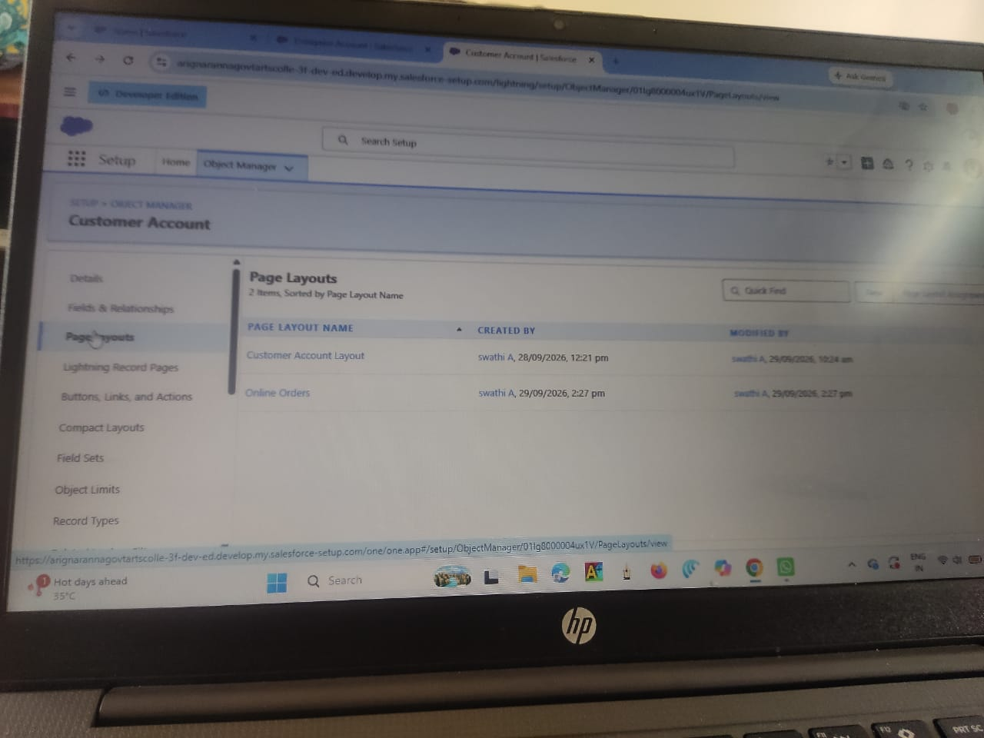

- Page Layout Name : Online Orders and click Save.

- Drag and Arrange all the required fields as shown below.

- Click Save.

Activity 2: Walk-In Orders page layout

- Go to the setup page → click on object manager → From drop down click edit for
Customer Account object.

- Click on the Page Layouts → click New.

- Page Layout Name : Walk-In orders and click save.

- Drag and Arrange all the required fields as shown below.

- Click Save.

Milestone 8 - Record Types
To Differentiate the records and data stored in Customer Accounts, let's create two different Record Types.
Online orders and Walk-In orders.

Activity 1: Online Orders Record Type

- Go to the setup page → click on object manager → From drop down click edit for
Customer Account object.

- Click on the Record Types → click New.

- Enter Details :
Existing Record Type : Master
Record Type Label : Online Order
Record Type Name : Auto Populates
Active : Tick the checkbox
Click Next

- In Assign Page Layouts
● Select Apply one layout to all profiles : select Online orders from the drop down menu.

- Click Save and New.

Activity 2: Walk-In Orders Record Type

- Go to the setup page → click on object manager → From drop down click edit for
Customer Account object.

- Click on the Record Types → click New.

- Enter Details :
Existing Record Type : Master
Record Type Label : Walk-In Order
Record Type Name : Auto Populates
Active : Tick the checkbox
Click Next

- In Assign Page Layouts
● Select Apply one layout to all profiles : select Walk-In orders from the drop down menu.

- Click Save.

Milestone 9 - Validation Rules

Activity 1: On Employer Account

- Go to the setup page → click on object manager → From drop down click edit for
Employer Account object.

- Click on the validation rule → click New.

- Enter Rule Name : Aadhar Number Error Condition Formula :
AND(
NOT(ISBLANK( Aadhar_Number__c )),
LEN( Aadhar_Number__c ) <> 12,
NOT(REGEX( Aadhar_Number__c , "^[1-9]{12}$"))
)

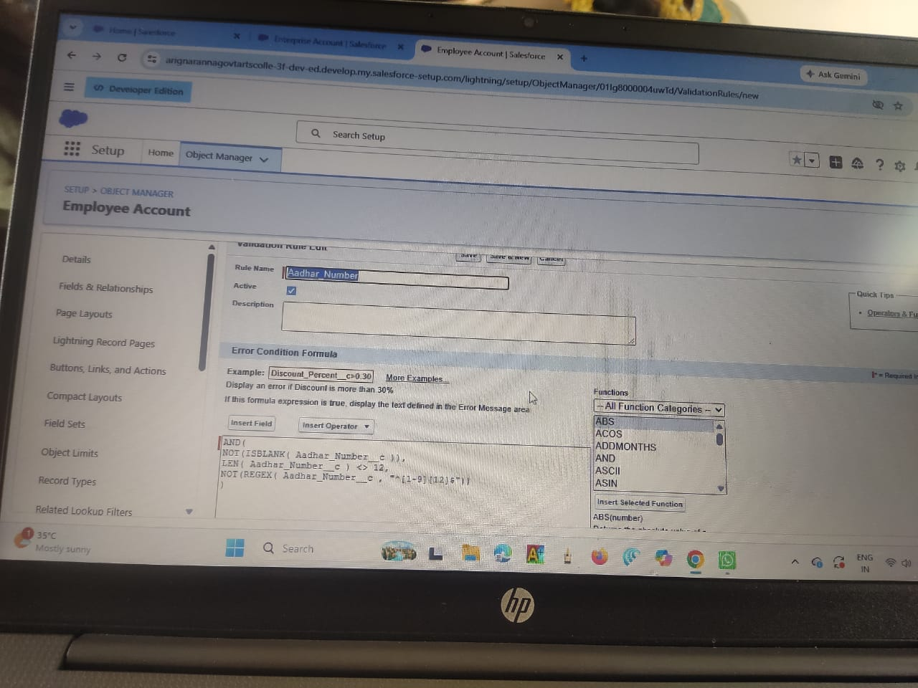

- Error Message : Aadhar number is required.
The Aadhar number must be 12 digits long.
Aadhar number can only contain numeric digits.
Aadhar number never starts with 0

- Click Save & New.

- Repeat the same steps and create two more validation rules on the employer account object.

  - Enter Rule Name : PAN Number Error Condition Formula :
AND(
NOT(ISBLANK( Phone_Number__c )),
NOT(REGEX( Phone_Number__c , "^[1-9]{10}$")),
NOT(REGEX( Phone_Number__c , "^\\d+$"))
)
Error Message : The PAN Details field must not be blank.
The PAN card number does not start with 0.
The PAN card number does not contain special characters.

Click Save & New.

  - Enter Rule Name : Phone Number Error Condition Formula :
AND(
NOT(ISBLANK( Phone_Number__c )),
NOT(REGEX( Phone_Number__c , "^[1-9]{10}$")),
NOT(REGEX( Phone_Number__c , "^\\d+$"))
)

Error Message :
The phone number field must not be blank.
The phone number must consist of exactly 10 digits.
The phone number must contain only numeric digits
(no spaces, dashes, parentheses, etc.)

Click Save.

Activity 2: On Customer Account

- Go to the setup page → click on object manager → From drop down click edit for
Customer Account object.

- Click on the validation rule → click New.

- Enter Rule Name : Phone Number

Error Condition Formula :
AND(
NOT(ISBLANK( Phone_Number__c )),
NOT(REGEX( Phone_Number__c , "^[1-9]{10}$")),
NOT(REGEX( Phone_Number__c , "^\\d+$"))
)

Error Message :
The phone number field must not be blank.
The phone number must consist of exactly 10 digits.
The phone number must contain only numeric digits
(no spaces, dashes, parentheses, etc.)

4. Click Save.

Activity 3: On Enterprise Account

- Go to the setup page → click on object manager → From drop down click edit for
Customer Account object.

- Click on the validation rule → click New.

- Enter Rule Name : Phone Number

Error Condition Formula :
AND(
NOT(ISBLANK( Phone_Number__c )),
NOT(REGEX( Phone_Number__c , "^[1-9]{10}$")),
NOT(REGEX( Phone_Number__c , "^\\d+$"))
)
Error Message :
The phone number field must not be blank.
The phone number must consist of exactly 10 digits.
The phone number must contain only numeric digits
(no spaces, dashes, parentheses, etc.)

4. Click Save.

Milestone 10 - Email Template

Activity 1: Email Template

- Go to setup, In quick find box enter Email template → click on classic Email Template.

- Click on→ New Email Template

- Choose the type of email template you would like to create : Text and click Next.

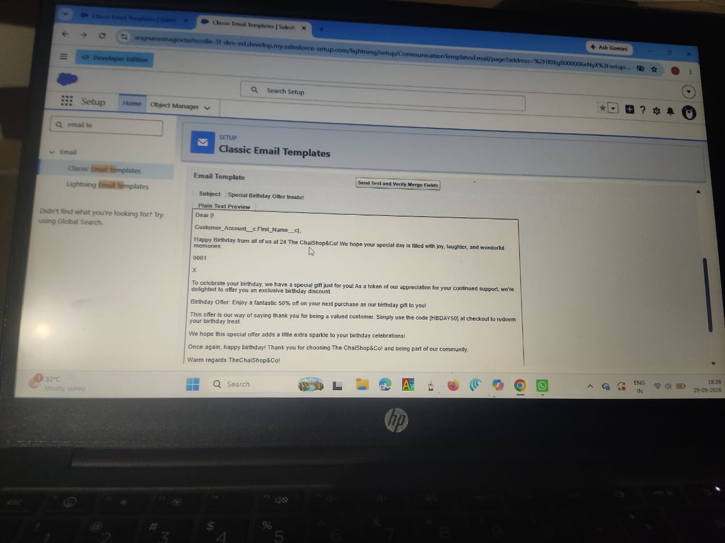

● Available Merge Fields
Select Field Type : Customer Accounts Fields
Select Field : First Name
Copy Merge Field value : Auto Populates, Copy the value and paste it in the email body where required.

- Folder : Unfiled public Classic Email templates
- Click on available for use
- Email Template Name is “Birthday Offer Email” 7. Template Unique Name : Auto populated
- Subject : Special Birthday Offer Inside!
- Email body :
Dear {!Customer_Account__c.First_Name__c},

Happy Birthday from all of us at TheChaiShop&Co! 🎉🎂 We hope your special day is filled with joy, laughter, and wonderful memories.

To celebrate your birthday, we have a special gift just for you! As a token of our appreciation for your continued support, we're delighted to offer you an exclusive birthday discount.

🎁 Birthday Offer: Enjoy a fantastic 50% off on your next purchase as our birthday gift to you!

This offer is our way of saying thank you for being a valued customer. Simply use the code [HBDAY50] at checkout to redeem your birthday treat.

We hope this special offer adds a little extra sparkle to your birthday celebrations!

Once again, happy birthday! Thank you for choosing TheChaiShop&Co! and being part of our community.

Warm regards TheChaiShop&Co!

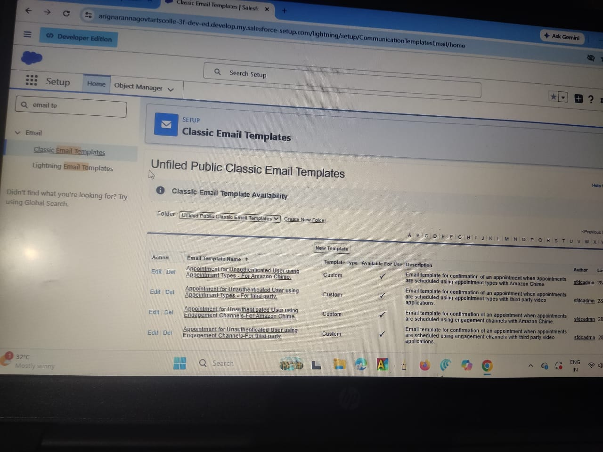

10. Click Save.

Activity 2: Email Alert

- Go to setup, In quick find box enter Email Alert → click on Email Alert .

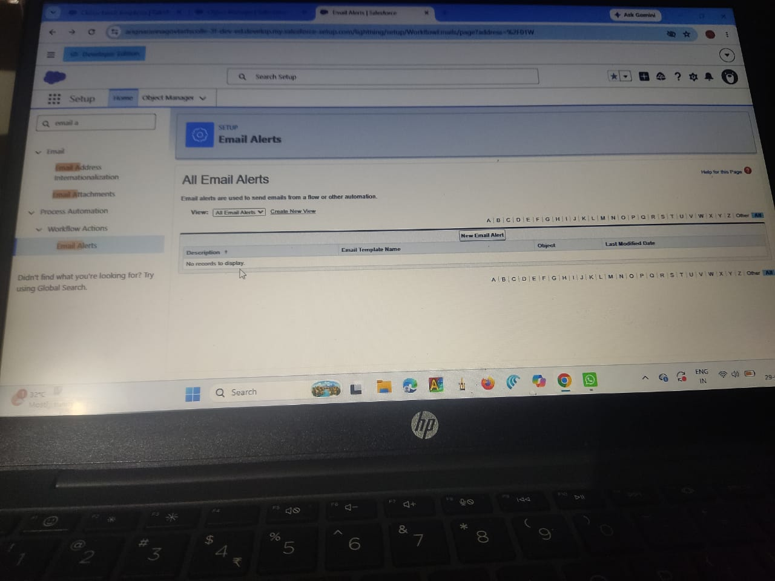

- Click on New Email Alert.

- Description : Happy Birthday email alert
Unique Name : Auto Populates
Object : Customer Account
Email Template : Search for Birthday Offer Email
Recipient Type : Search : Email field : Email ID
From Email Address : Default Workflow user’s email address Click Save.

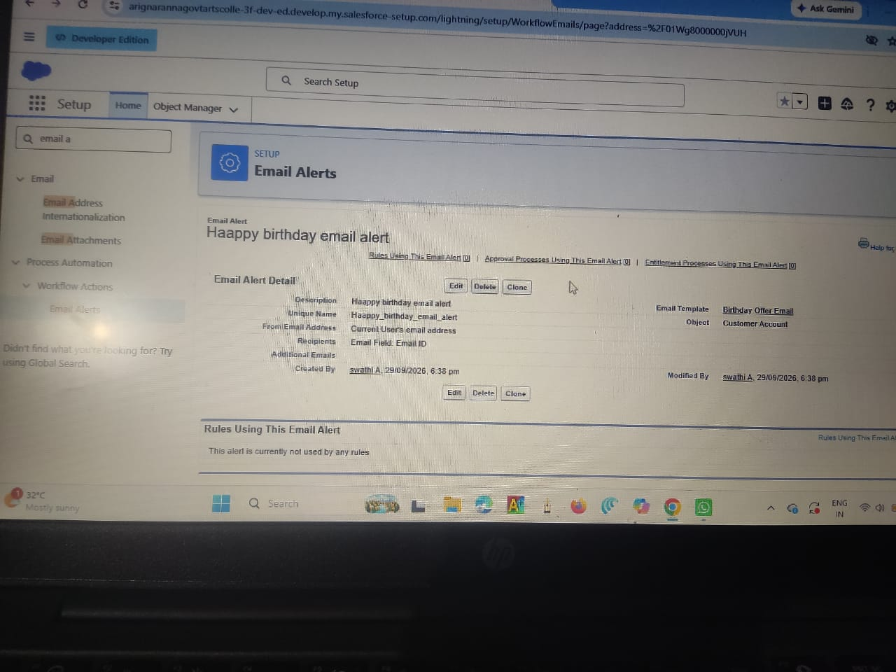

NOTE :

1. Make sure that the Default workflow user is assigned.

Milestone 11 - Flows
Let’s create a scheduled Triggered flow to automate the Birthday offer mails.

Activity 1: Schedule Triggered Flow

- Go to setup, Type Flow in quick find box → Click on the Flow and Select the New Flow.

- Select Schedule - Triggered Flow and click Create.
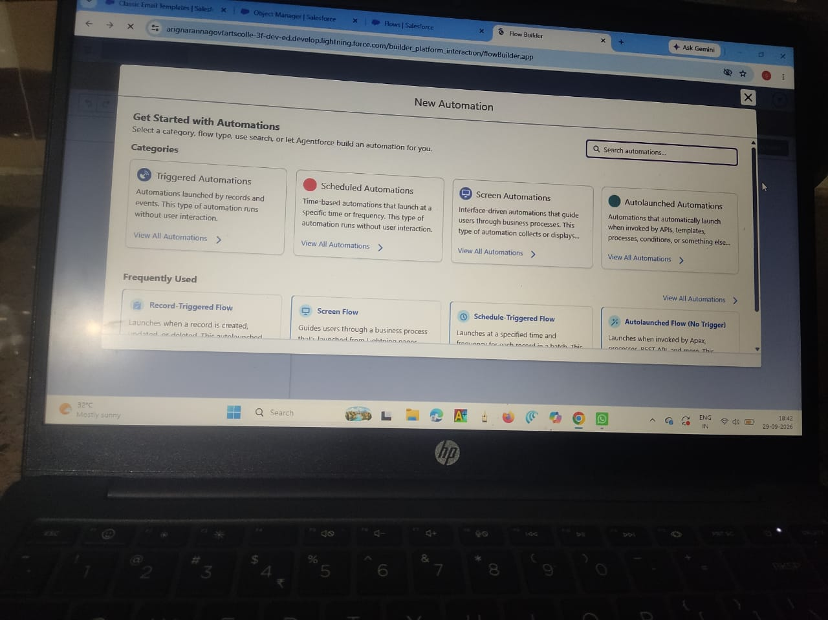

- Set a Schedule
Start Date : Enter the Date, when you want to start the flow.
Start Time : Enter the Time, when you want to start the flow.
Frequency : Daily

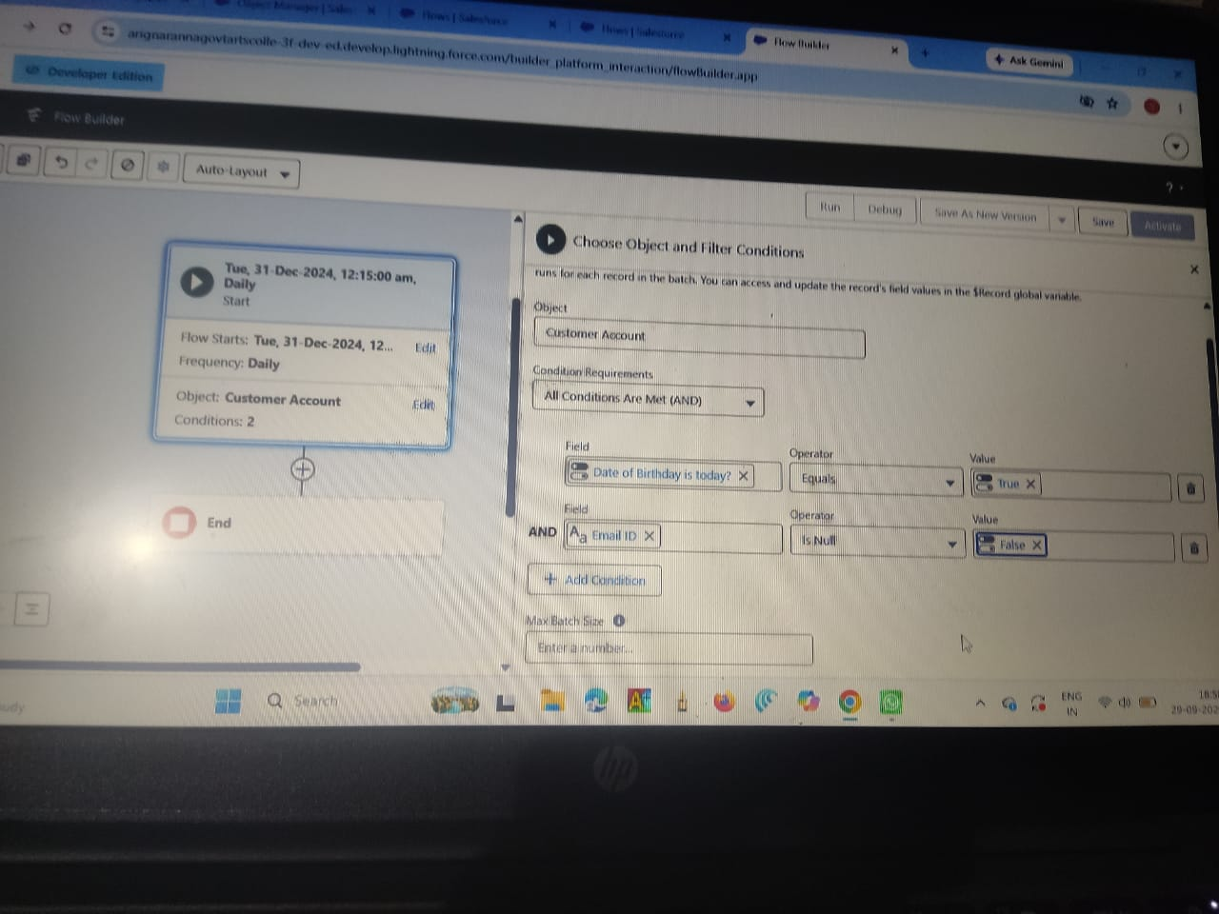

- Create Object
Object : Customer Account
Condition Requirements : All conditions Are Met (AND)
  - Field : Date_of_Birthday_is_today__c
Operator : Equals
Value : $GlobalConstant.True
  - Field : Email_ID_c
Operator : IS NULL
Value : $GlobalConstant.False

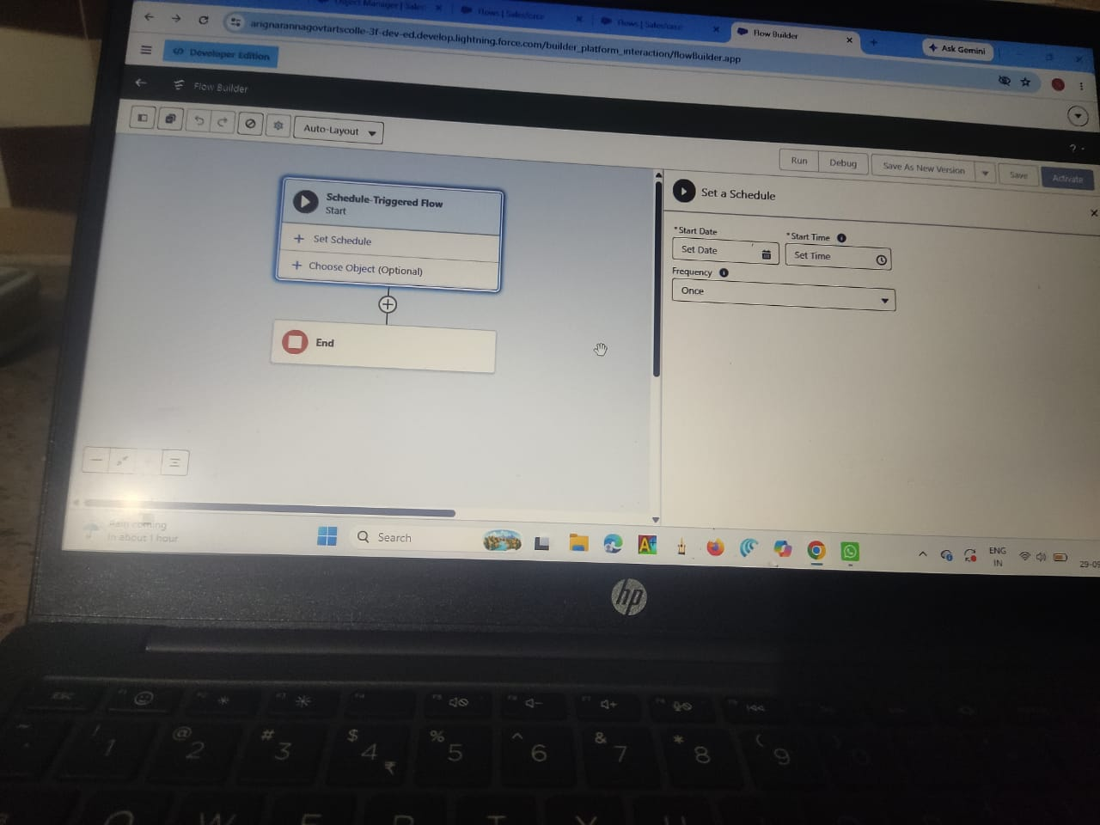

- Click (+) Icon on the flow builder and Select Action Component.

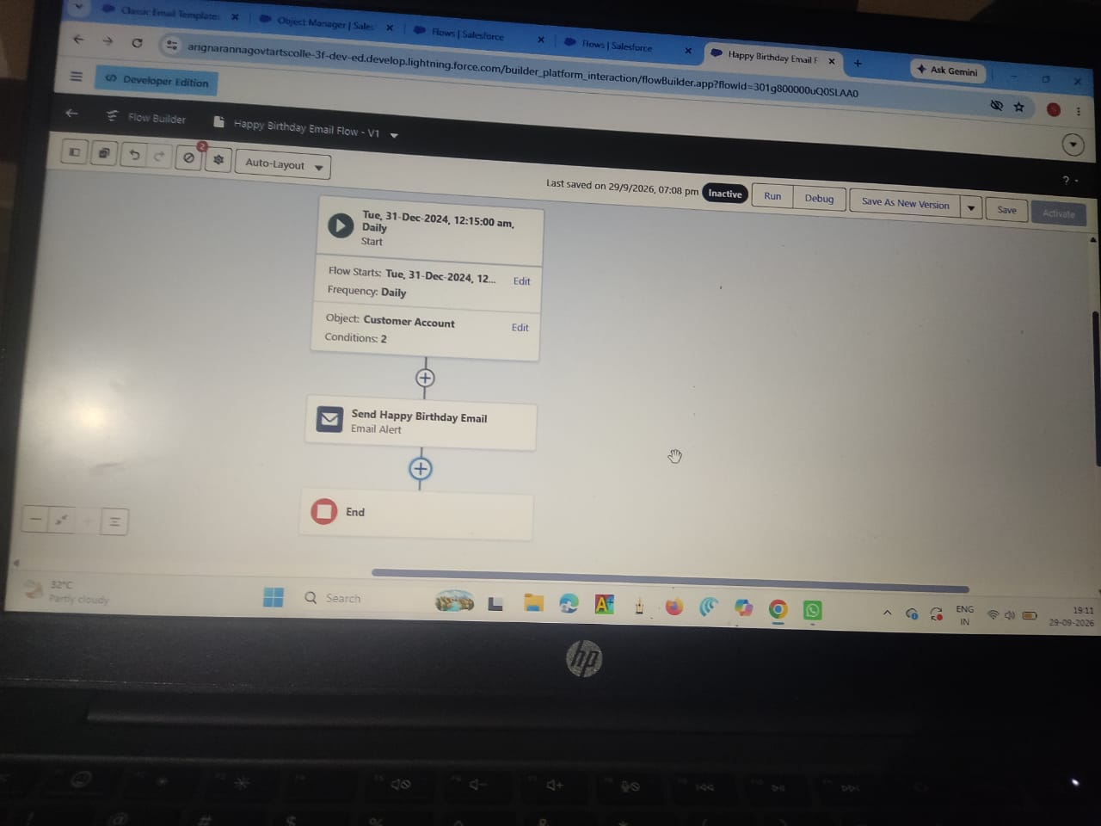

- In New Action Page
Filter By : Type and select Email Alert
In Action : Search and select Happy Birthday email alert
Label : Send Happy Birthday Email
API Name : Auto Populates
Set Input Values for the Selected Action : Record ID : {!$Record.Id}

- Click Done.

- Click Save on the top right
Flow Label : Happy Birthday Email Flow Flow API Name : Auto Populates Click Save.

- Click Activate.

Milestone 12 - Reports & Dashboards

Activity 1: Customer Account Sales Report
- Click App Launcher  and select TheChaiShop&Co.
- Click Reports
- Click New Report

- In search type Customer Accounts and Select Customer Accounts.
- Click Start Report.

- Click the toggle Update Preview Automatically to ON.
- Drag and Drop all the required Columns from the Outline pane.
- Group Rows : Search and Select
Customer Account: Record Type
- Click Add Chart on the top.

- Click Save on the top right.
Enter
Report Name: Customer Account Sales Report
Report Unique Name : Auto Populates
Click Save.

Activity 2: Enterprise Account Sales Report
- Repeat the same steps to create another report.
- Click Reports
- Click New Report
- In search type Enterprise Accounts and Select Enterprise Accounts.
- Click Start Report.
- Click the toggle Update Preview Automatically to ON.
Drag and Drop all the required Columns from the Outline pane.
Group Rows : Search and Select Type of Items.
- Click Add Chart on the top.

- Click Save on the top right.
  - Enter
  - Report Name : Enterprise Account Sales Report
  - Report Unique Name : Auto Populates
  - Click Save.

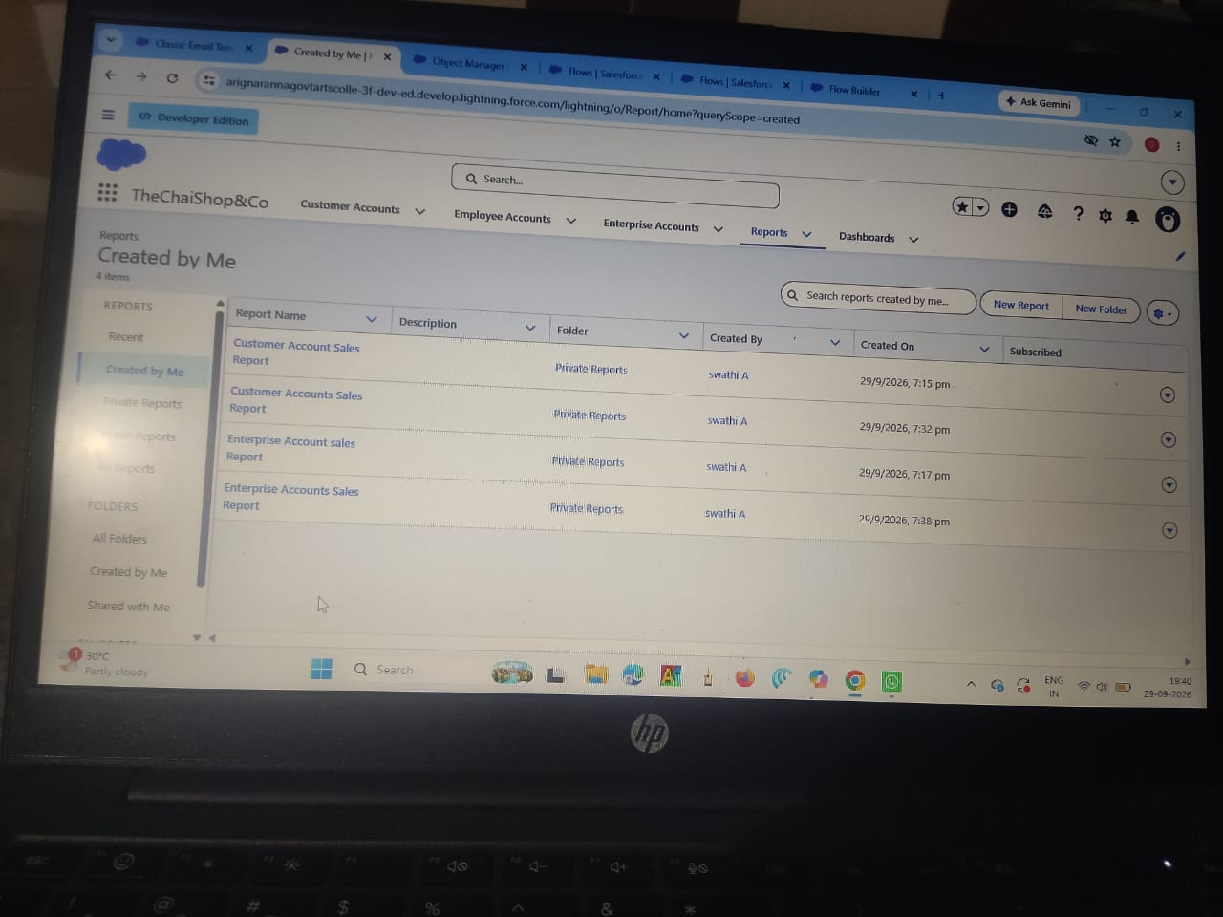

Activity 3: Dashboard

- Click Dashboards
- Click New Dashboards

- Name : Customer Vs Enterprise Sales 4. Click Create.

- Click Widget
- Select Chart or Table.

- Select Customer Account Sales Report

- Display As : Select the one which you feel comfortable with.
- Click Add.
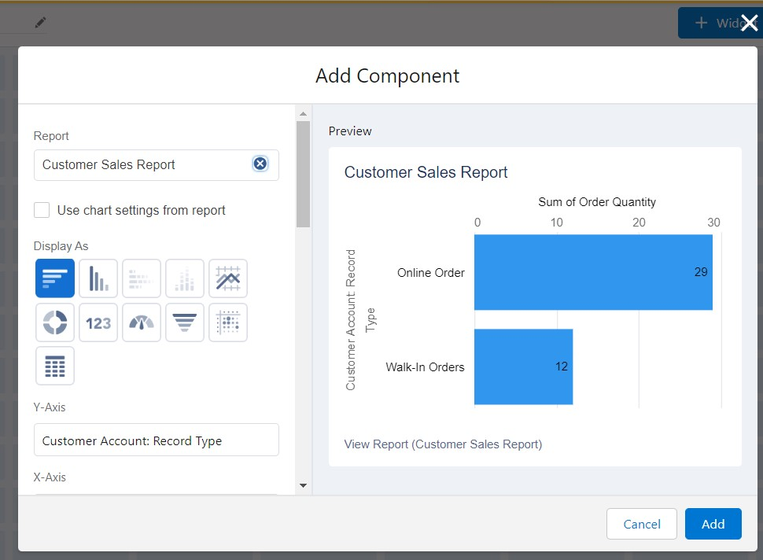

- Repeat the same steps for the Enterprise Account Sales Report.
- Click Save.

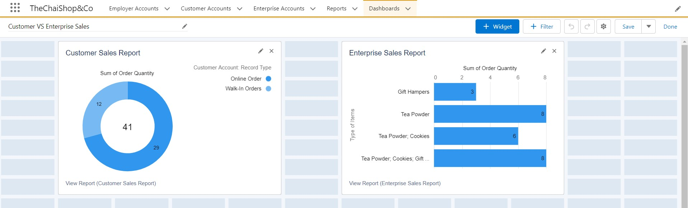

Milestone 12 - Conclusion

In conclusion, the implementation of Salesforce CRM for The Chai Shop & Co. marks a pivotal transformation in the store's operational efficiency and customer relationship management. By centralizing enterprise data, employee details, and both online and offline customer records into a single platform, the application successfully streamlines business workflows and equips management with real-time insights for informed decision-making.
​Key automations—such as instant sales calculations for order quantities and total bill amounts—eliminate manual calculation errors and significantly reduce repetitive administrative tasks. This efficiency allows staff to devote more time to delivering exceptional customer service. Furthermore, automated birthday email notifications enable timely, personalized communication, deepening customer engagement and loyalty. Ultimately, Salesforce CRM provides The Chai Shop & Co. with a scalable foundation to sustain growth, optimize daily operations, and build lasting customer relationships.

7.FUNCTIONAL & PERFORMANCE TESTING
Functional Testing
​Functional testing for The Chai Shop & Co. CRM application evaluates every system module against established business requirements to verify operational accuracy. Core verification begins with data management, ensuring that both online and offline customer records, along with employee details, can be created and updated without errors. Functional checks validate that customer interactions—such as logging service requests, tracking inquiries, and capturing preferences—are correctly linked to corresponding account profiles. Crucially, testing confirms that system automations function as expected: field-level logic must accurately compute sales figures, including order quantities and total bill amounts, without manual intervention. Additionally, scheduled workflow rules are tested to guarantee that personalized birthday email notifications automatically trigger and send to customers on their respective birth dates. Finally, functional tests ensure that custom reports and dashboards pull live transaction data accurately, giving the owner real-time operational insights.
​Performance Testing
​Performance testing evaluates the speed, stability, and scalability of the Salesforce CRM application under standard and peak workload conditions. Load testing simulates multi-user scenarios during peak shop hours—with over 50 employees and online orders entering sales data concurrently—to ensure page response times stay under two seconds and record creation remains seamless. Automation stress tests verify that batch processing for sales totals and order calculations executes within governor limits without introducing system lag. System reliability is also tested during scheduled batch triggers, verifying that high-volume automated processes—such as delivering hundreds of birthday email notifications simultaneously—complete without execution timeouts or failed email queues. Lastly, report and dashboard performance is tested against large volumes of historical customer data to ensure complex analytical summaries render in under three seconds, supporting swift operational decision-making.

8. ADVANTAGES & DISADVANTAGES
​Advantages
​Implementing Salesforce CRM provides The Chai Shop & Co. with a centralized system that unifies employee details and both online and offline customer records, eliminating data silos across sales channels. The primary operational benefit is the automation of key processes, such as automatic sales calculations for order quantities and total bill amounts, which eliminates manual arithmetic errors and speeds up the checkout process. Reducing these repetitive administrative tasks frees up staff to focus on delivering exceptional customer service. Additionally, automated birthday email notifications foster personalized customer engagement and strengthen brand loyalty. Finally, real-time reports and visual dashboards give the business owner immediate clarity on sales performance, enabling informed, data-driven decisions to support business growth.
​Disadvantages
Despite its operational benefits, implementing a CRM system like Salesforce introduces certain challenges for a growing shop. Initial adoption requires an investment of time and resources for employee training, as staff must transition from manual processes to a digital system. Over-reliance on automated workflows means that system outages or connectivity issues could temporarily impact order entry or communication delivery. Customizing fields, maintaining data accuracy across online and offline channels, and managing automated rules require ongoing system administration. Additionally, as the business scales, recurring licensing costs for CRM software and potential technical maintenance can add to operating overhead.
9. Conclusion:

The implementation of Salesforce CRM transforms The Chai Shop & Co. from a manually run store into a digitally organized, customer-centric enterprise. By centralizing online and offline customer records, automating sales calculations, and delivering personalized birthday communications, the application eliminates operational bottlenecks and boosts customer engagement. Ultimately, the system empowers employees to deliver better service while equipping the owner with real-time insights to drive business growth.
​

10. FUTURE SCOPE
​Looking ahead, The Chai Shop & Co. can expand its CRM system by integrating a dedicated Loyalty & Rewards Program directly within Salesforce to automatically track customer points and offer customized discounts. Integrating AI-driven Predictive Analytics (such as Salesforce Einstein) can help forecast inventory demand, identify peak chai-buying hours, and recommend preferred products based on individual purchase histories. Expanding to Omnichannel Customer Support by adding WhatsApp, SMS, and live website chat integrations will allow customers to place orders, raise service requests, or check store menus seamlessly. Finally, implementing Mobile App Integration for both employees and field staff can streamline inventory tracking, delivery updates, and real-time order processing on the go.

11. APPENDIX
Source Code : Salesforce Configuration & Flows
Dataset : Customer and Sales Records
Tools Used : Salesforce Developer Org

Thank You

